# RETAILER MANAGEMENT SYSTEM

SUBMITTED BY-

G.ATHUL SAI SHRAVAN (1401018)

BISWA BHUSAN SOREN (1401015)

**CONTENTS**

1. OVERVIEW
2. ARCHITECTURE

* SOFTWARE REQUIREMENTS
* FRAMEWORKS USED
* DATABASE USED

1. IMPLEMENTATION
2. PREVIOUS PLAN
3. CURRENT PLAN
4. DRAWBACKS
5. UML DIAGRAMS

* USE CASE DIAGRAM
* ACTIVITY DIAGRAM
* SWIMLANE DIAGRAM
* SEQUENCE DIAGRAM
* STATECHART DIAGRAM
* CLASS DIAGRAM
* ER DIAGRAM
* ARCHITECTURE DIAGRAM
* COMPONENT LEVEL DIAGRAM
* DATA FLOW DIAGRAM

1. FUNCTIONALITY
2. CONSTRUCTION AND CODING
3. APPLICATION SCREENSHOTS
4. TEST CASES
5. CONCLUSION

**Overview**

With the increase in today’s demand a retailer itself cannot cope up with the work load.

This application gives a relief to the retailer as with the increase in their customers the workload increase to take their orders bring them down from the store, pack them and prepare the bill.

As this system provide facility from front side as well as back side. More specifically using this application customer can order as well as bill for himself.

The retailer himself need not have to calculate and make effort to prepare the bill all it have to do is to pack the goods and take the money.

Now for the admin side using a specific credentials the retailer can fix the price for a specific products and can add or remove the product from the list.

**Architecture**

**Software Requirements**

* Git Bash terminal
* Node JS installed(Express installed)
* Mongodb installed
* Sublime Text editor
* Mongodb Compass installed
* OS used WINDOWS

**Frame Work Used**

**Node Js:**

Node.js is an [open-source](https://en.wikipedia.org/wiki/Open-source_software), [cross-platform](https://en.wikipedia.org/wiki/Cross-platform) [JavaScript](https://en.wikipedia.org/wiki/JavaScript) [run-time environment](https://en.wikipedia.org/wiki/Runtime_system) for executing JavaScript code [server-side](https://en.wikipedia.org/wiki/Server-side), and uses the [Chrome V8](https://en.wikipedia.org/wiki/Chrome_V8) [JavaScript engine](https://en.wikipedia.org/wiki/JavaScript_engine).  Node.js enables JavaScript to be used for [server-side scripting](https://en.wikipedia.org/wiki/Server-side_scripting), and runs scripts server-side to produce [dynamic web page](https://en.wikipedia.org/wiki/Dynamic_web_page) content before the page is sent to the user's web browser. Consequently, Node.js has become one of the foundational elements of the "JavaScript everywhere" paradigm, allowing [web application](https://en.wikipedia.org/wiki/Web_application) development to unify around a single programming language, rather than rely on a different language for writing server side scripts.

**Angular Js:**

AngularJS  is a JavaScript-based [open-source](https://en.wikipedia.org/wiki/Open-source_software) front-end [web application framework](https://en.wikipedia.org/wiki/Web_application_framework) mainly maintained by [Google](https://en.wikipedia.org/wiki/Google) and by a community of individuals and corporations to address many of the challenges encountered in developing [single-page applications](https://en.wikipedia.org/wiki/Single-page_application). It aims to simplify both the development and the [testing](https://en.wikipedia.org/wiki/Software_testing) of such applications by providing a framework for client-side [model–view–controller](https://en.wikipedia.org/wiki/Model%E2%80%93view%E2%80%93controller) (MVC) and [model–view–viewmodel](https://en.wikipedia.org/wiki/Model_View_ViewModel) (MVVM) architectures, along with components commonly used in [rich Internet applications](https://en.wikipedia.org/wiki/Rich_Internet_application).

The AngularJS framework works by first reading the [HTML](https://en.wikipedia.org/wiki/HTML) page, which has embedded into it additional custom [tag attributes](https://en.wikipedia.org/wiki/HTML_attribute). Angular interprets those attributes as [directives](https://en.wikipedia.org/wiki/Directive_(programming)) to bind input or output parts of the page to a model that is represented standard [JavaScript](https://en.wikipedia.org/wiki/JavaScript) [variables](https://en.wikipedia.org/wiki/Variable_(computer_science)). The values of those JavaScript variables can be manually set within the code, or retrieved from static or dynamic [JSON](https://en.wikipedia.org/wiki/JSON) resources.

**Express:**

Express.js or simply Express, is a [web application framework](https://en.wikipedia.org/wiki/Web_application_framework) for [Node.js](https://en.wikipedia.org/wiki/Node.js).  Express is the backend part of the [MEAN stack](https://en.wikipedia.org/wiki/MEAN_(software_bundle)), together with [MongoDB](https://en.wikipedia.org/wiki/MongoDB) database and [AngularJS](https://en.wikipedia.org/wiki/AngularJS) frontend framework.

**Database Used**

**Mongodb:**

MongoDB is a [free and open-source](https://en.wikipedia.org/wiki/Free_and_open-source_software) [cross-platform](https://en.wikipedia.org/wiki/Cross-platform) [document-oriented database](https://en.wikipedia.org/wiki/Document-oriented_database) program. Classified as a [NoSQL](https://en.wikipedia.org/wiki/NoSQL) database program, MongoDB uses [JSON](https://en.wikipedia.org/wiki/JSON)-like documents with [schemas](https://en.wikipedia.org/wiki/Database_schema).

**Implementation**

An application to implement two different part of retailer management system i.e Retailer or Customer.

In this web application customer can create its account and can buy products and can cancel the order as well .

And also the retailer can be able to see the orders given by the customer and can deliver the product. The retailer can also change the product prices, names, stocks accordingly.

**Previous plan**

To create a simple non – GUI interface for customer to implement Retailer management system.

**Current Plan**

To develop a web based application (MEAN Stack Application) with user friendly GUI using node js and express as backend and angular js for frontend and database used is mongodb.

**Drawbacks**

No security guarantees.

**UML Diagram**

**Use Case Diagram:**

The purpose of use case diagram is to capture the dynamic aspect of a system.  Used to gather requirements of a system. Used to get an outside view of a system. Identify external and internal factors requirements are actors.

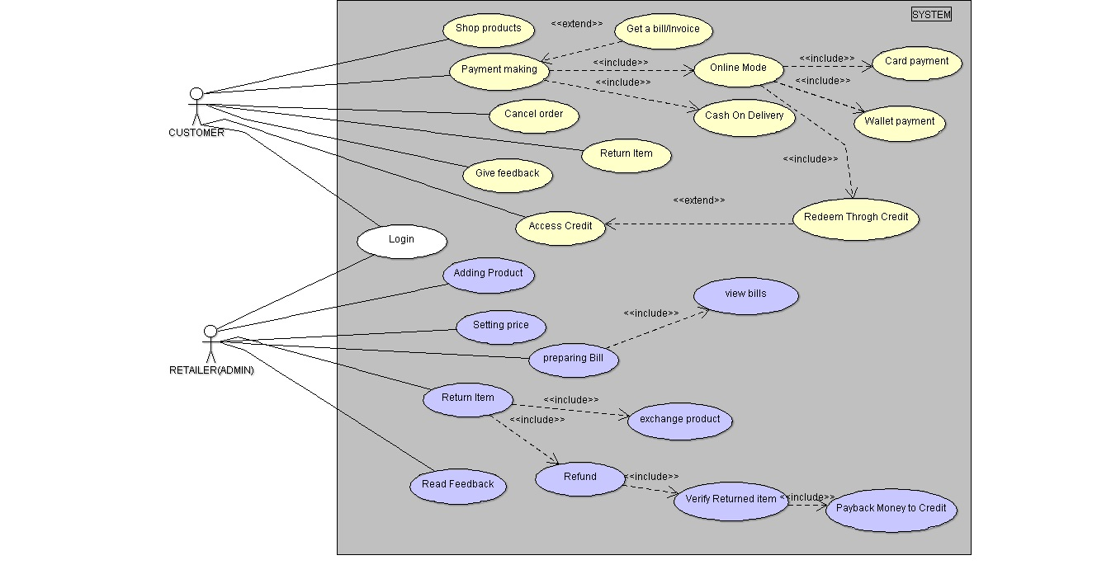

Above is the use case diagram for retailer management system.

**Activity Diagram:**

Activity diagram is basically a flow chart to represent the flow from one activity to another activity. The activity can be described as an operation of the system.  It captures the dynamic behaviour of the system. Activity diagram is used to show message flow from one activity to another. It is used to draw the activity flow of a system, describe the sequence from one activity to another, describe the parallel, branched and concurrent flow of the system.

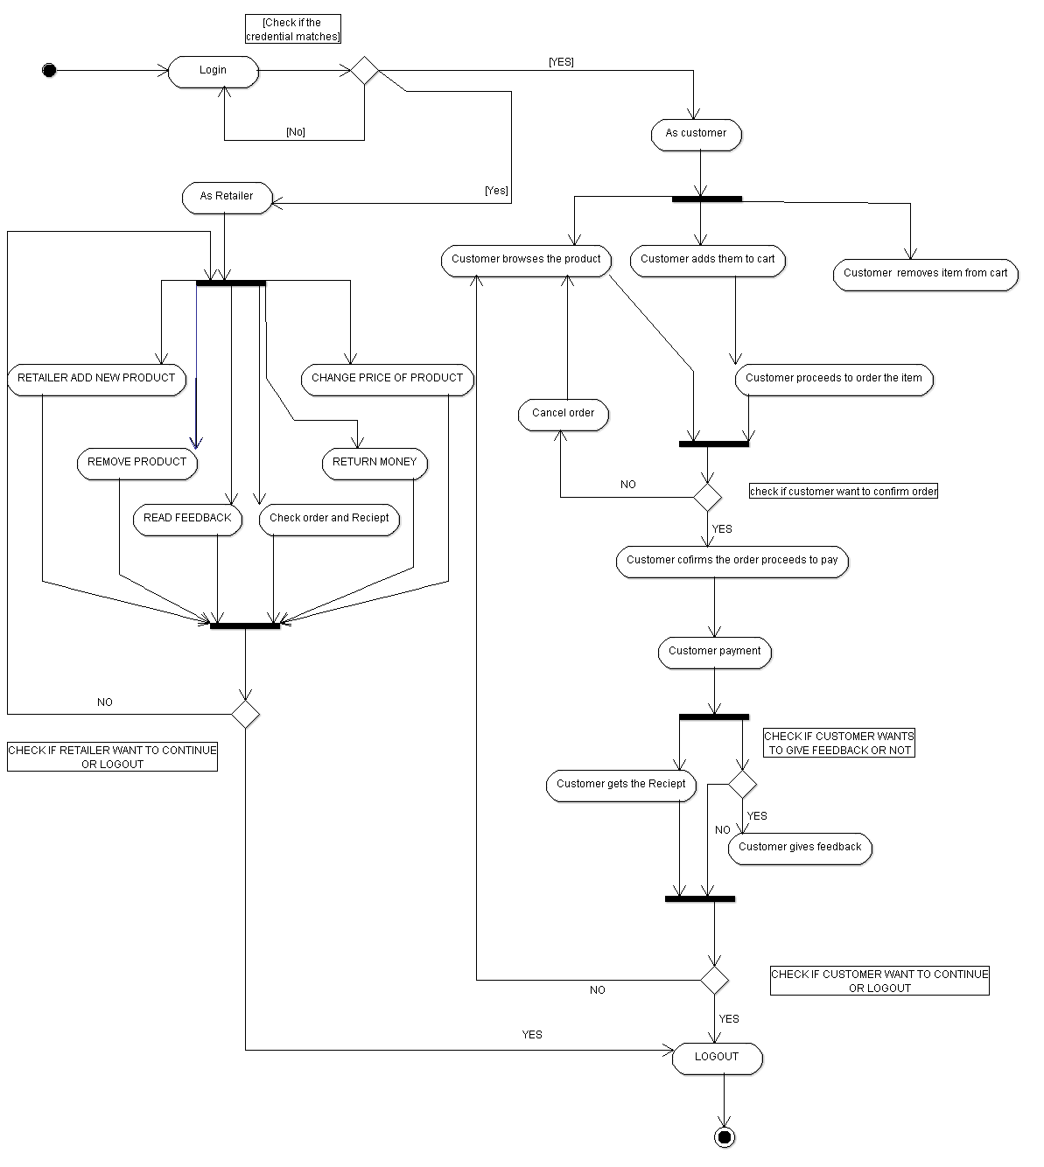

Above is the activity diagram for retailer management system.

**Swimlane Diagram:**

A swim lane  is a visual element used in process flow diagrams, or flowcharts, that visually distinguishes job sharing and responsibilities for sub-processes of a business process. Swim lanes may be arranged either horizontally or vertically.

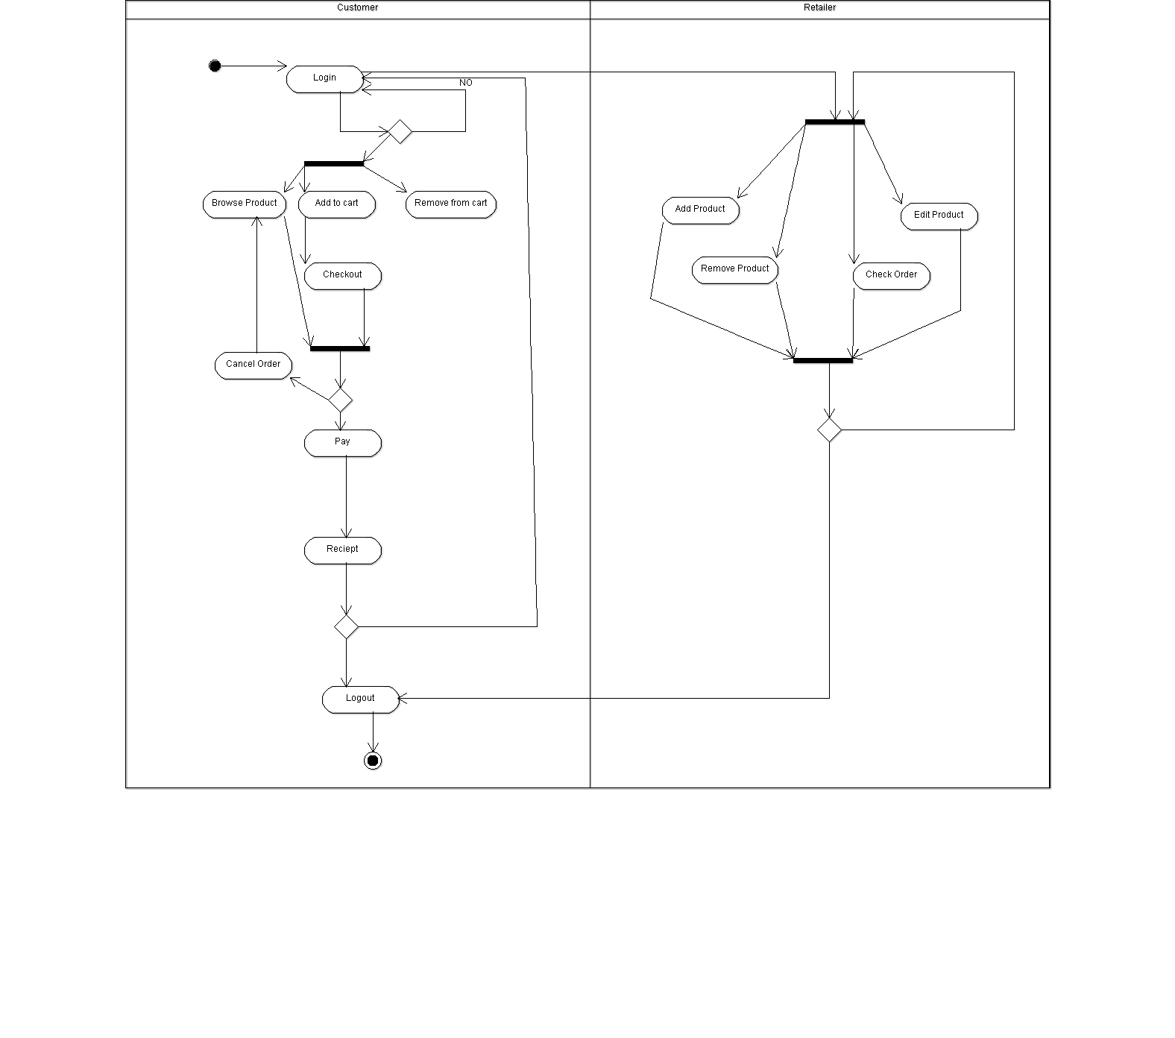

Above is the swimlane diagram for retailer management system.

**Statechart Diagram:**

 Statechart diagram describes different states of a component in a system. The states are specific to a component/object of a system. It describes the flow of control from one state to another state. To model dynamic aspect of a system. The main purpose of state diagram is o model life time of a reactive system, to describe different states of an object during its life time, define a state machine to model states of an object.

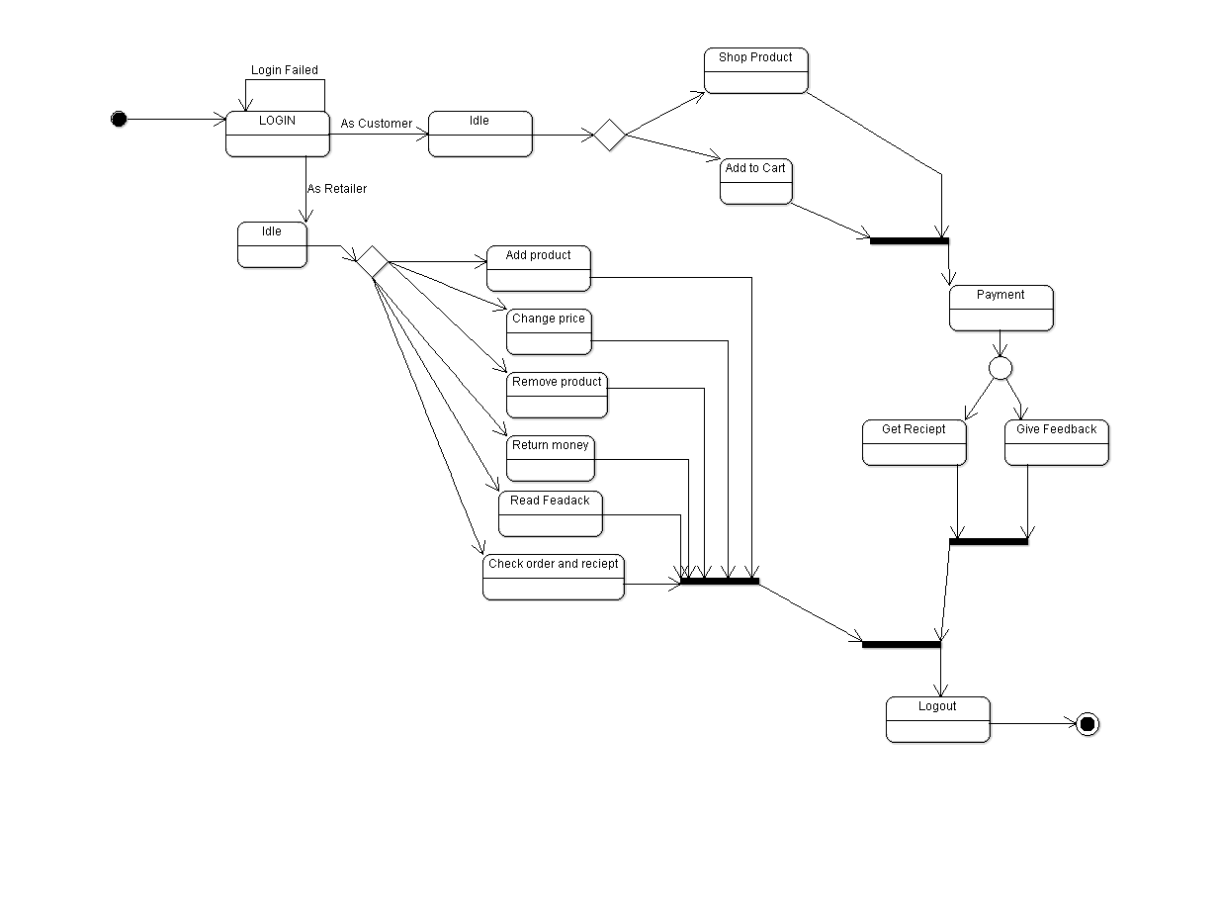

Above is the activity diagram for retailer management system.

**Sequence Diagram:**

Sequence diagrams are a kind of interaction diagram. They describe how and in what order a group of objects works together. These diagrams are used to understand requirements for a new system or to document an existing process.

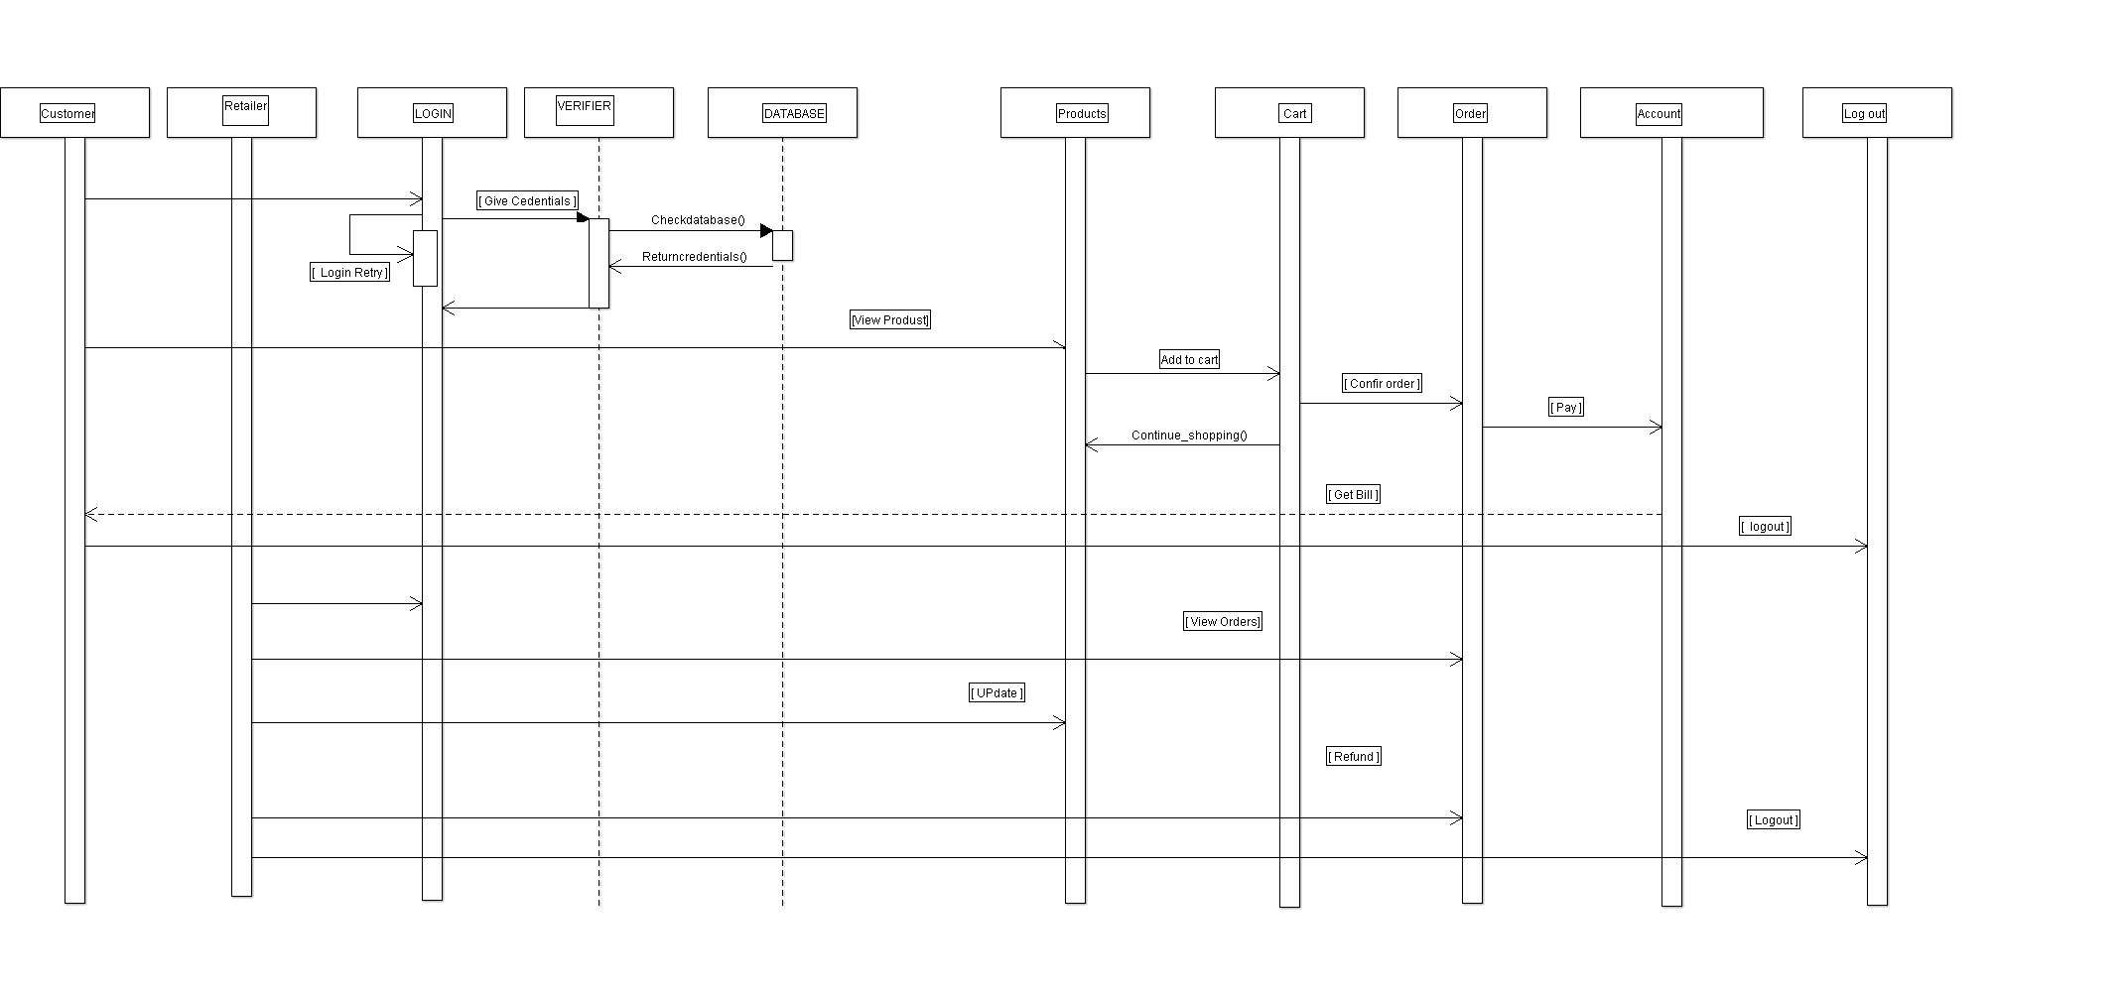

Above is the sequence diagram for retailer management system.

**Class Diagram:**

The class diagram is a static diagram. It represents the static view of an application. The class diagram describes the attributes and operations of a class. The class diagrams are the only diagrams which can be directly mapped with object oriented languages and thus widely used at the time of construction.

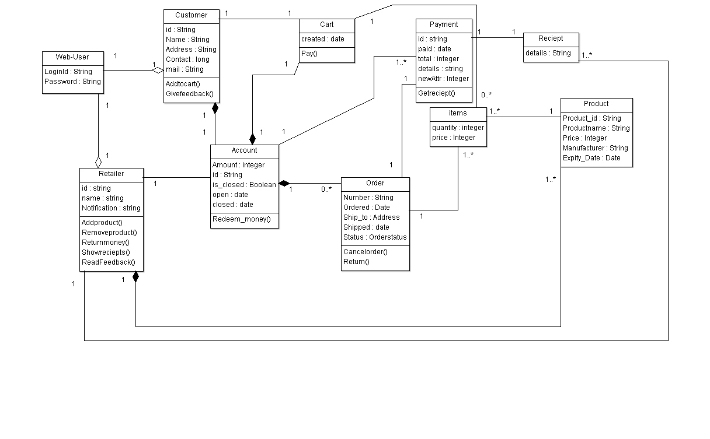

Above is the Class diagram for retailer management system.

**ER Diagram:**

An entity relationship diagram shows the relationships of entity sets stored in a database. An entity in this context is a component of data. ER diagrams illustrate the logical structure of databases.  An ER model is composed of entity types and specifies relationships that can exist between instances of those entity types.

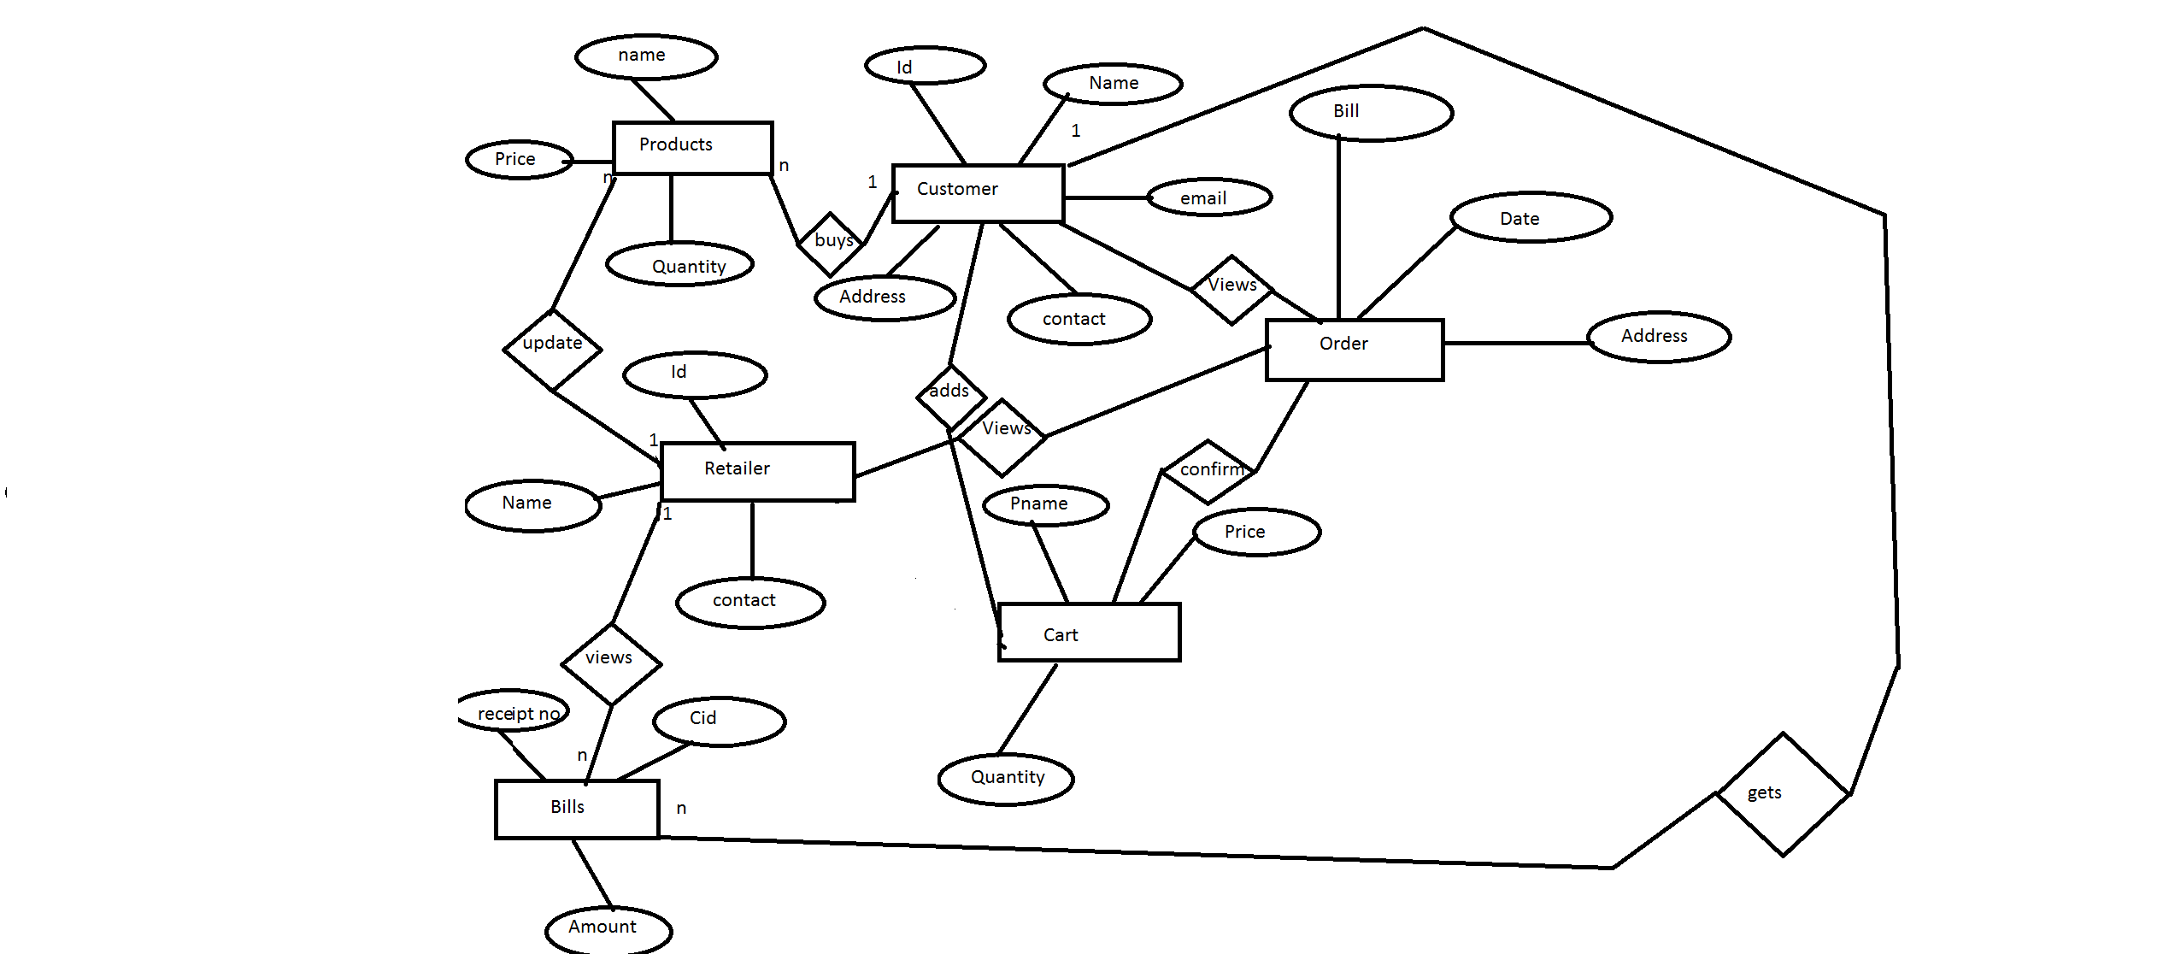

Above is the ER diagram for retailer management system.

**Architecture Diagram:**

Architectural Design represents the structure of the data and program components that are required to build computer based system.

An Architectural Design model is transferable. It represents a set of abstractions that enables software engineers to describe architecture in predictable ways

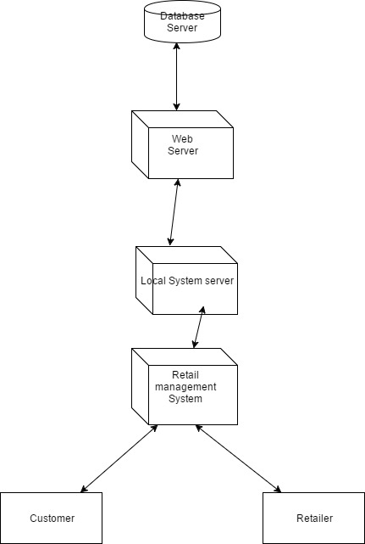

Above is the Architecture diagram for retailer management system.

**Component Level Diagram:**

The component-level design represents the software in a way that allows the designer to review it for correctness and consistency, before it is built. The work product produced is a design for each software component, represented using graphical, tabular, or text-based notation. Design walkthroughs are conducted to determine correctness of the data transformation or control transformation allocated to each component during earlier design steps.

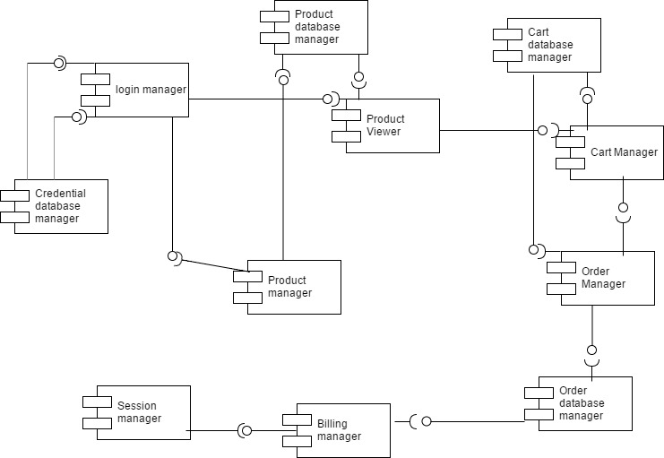

Above is the Component Level diagram for retailer management system.

**Data Flow Diagrams:**

 A Data Flow Diagram (DFD) is traditional visual representation of the information flows within a system. It shows how information enters and leaves the system, what changes the information and where information is stored. The purpose of a DFD is to show the scope and boundaries of a system as a whole. It may be used as a communications tool between a systems analyst and any person who plays a part in the system that acts as the starting point for redesigning a system.

It is usually beginning with a context diagram as the level 0 of DFD diagram, a simple representation of the whole system. To elaborate further from that, we drill down to a level 1 diagram with lower level functions decomposed from the major functions of the system. This could continue to evolve to become a level 2 diagram when further analysis is required.

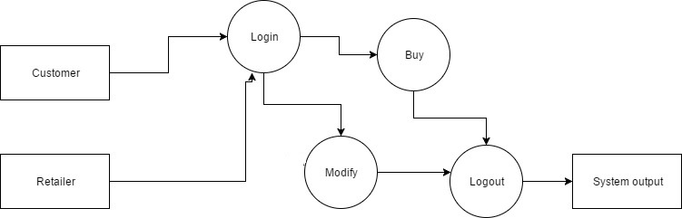

Level 0 DFD retailer management system

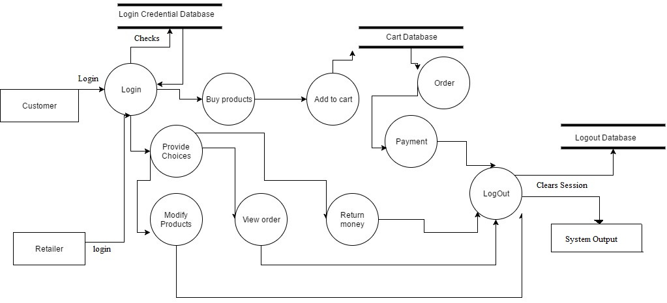

Level 1 DFD of retailer management system

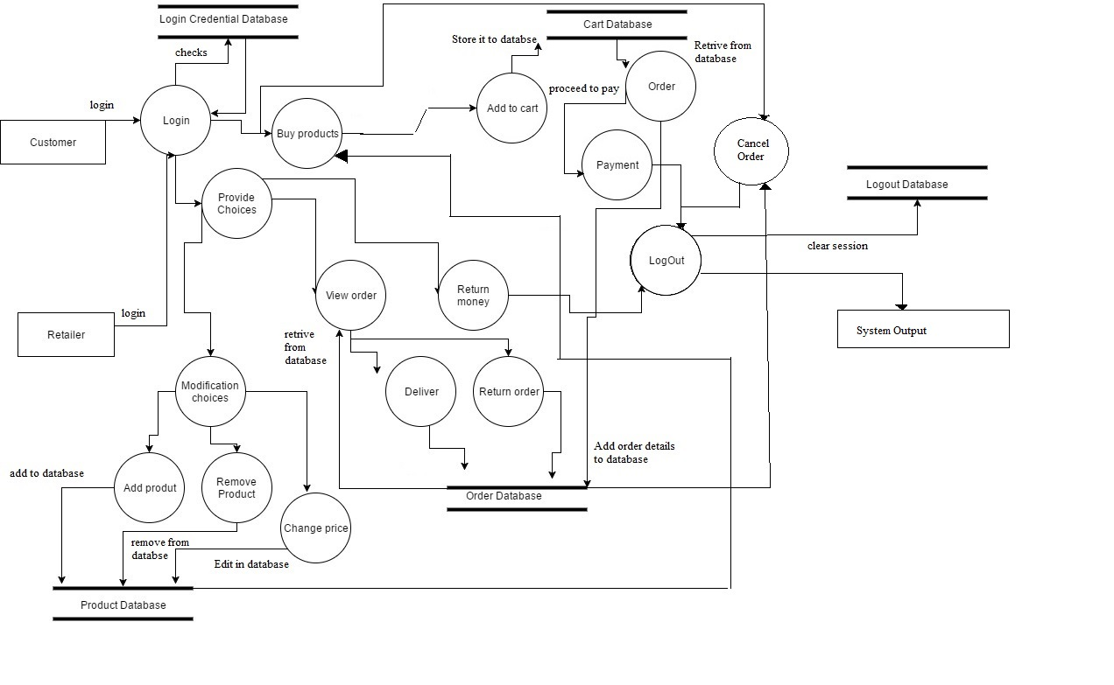

Level 2 DFD of retailer management system

**Functionality**

**Customer**

* Add items to cart
* Remove items from cart
* View profile
* Edit profile
* View previous Orders
* Check out
* Change order status(like from active to cancel and delivered to return)

**Retailer**

* See Order Details
* Change Order status(like active to delivered and return to returned or active to out of stock)
* Add Product
* Delete Product
* Edit Product Details

**Construction and Coding-**

Backend-

The backend part has been written in nodejs constructing independent API to run asynchronously.

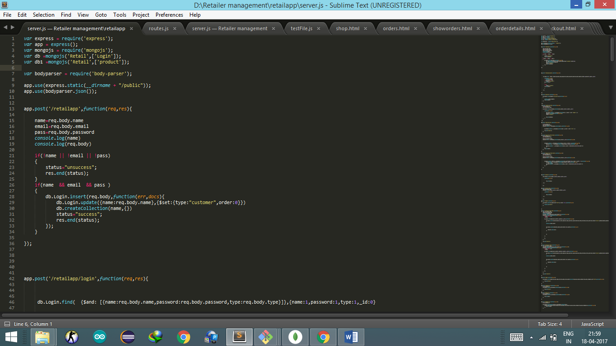

Figure 1:Server.js

This is server.js file where all the API has been written as it could put or retrieve data from data base.

Here,

**app.post ('/retailapp',function(req,res){**

This is called an API which will is a post method and the url used to define it is ‘/retailapp’

In this file 27 such API’s has been defined which are get,post and put methods.

Each of the API uses the MongoDB database to retrieve and put data into.

db.Login.insert(req.body,function(err,docs){

db.Login.update({name:req.body.name},{$set:{type:"customer",order:0}})

db.createCollection(name,{})

This a small part of code that show how to insert,update and create collections in the data base.

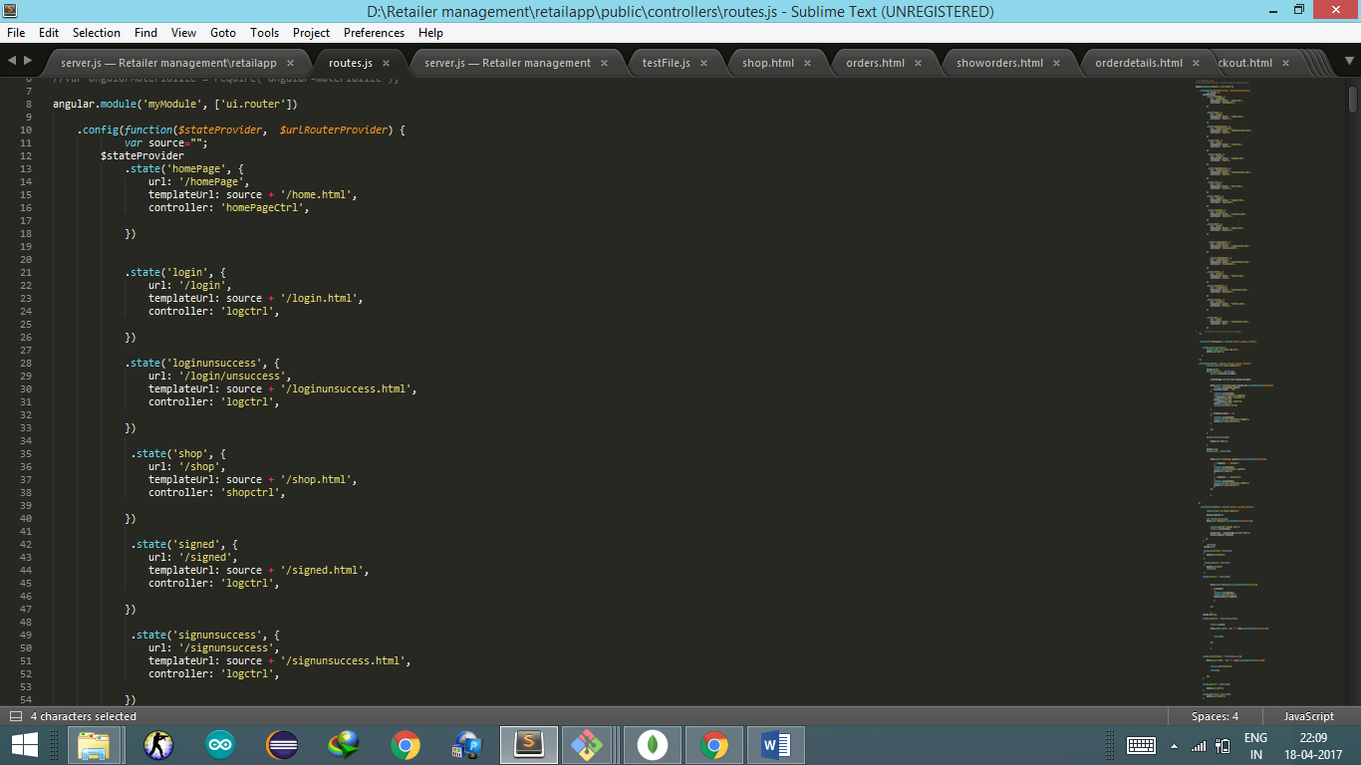

Figure 2:Router.js

In this File all the routes (states) has been defined with their respective url and controllers. This file is used to route the html file with the change in states from one html page to other.

.state('login', {

url: '/login',

templateUrl: source + '/login.html',

controller: 'logctrl',

})

This is an example of a state where ‘/login’ is the url and logctrl is the controller associated with login.html

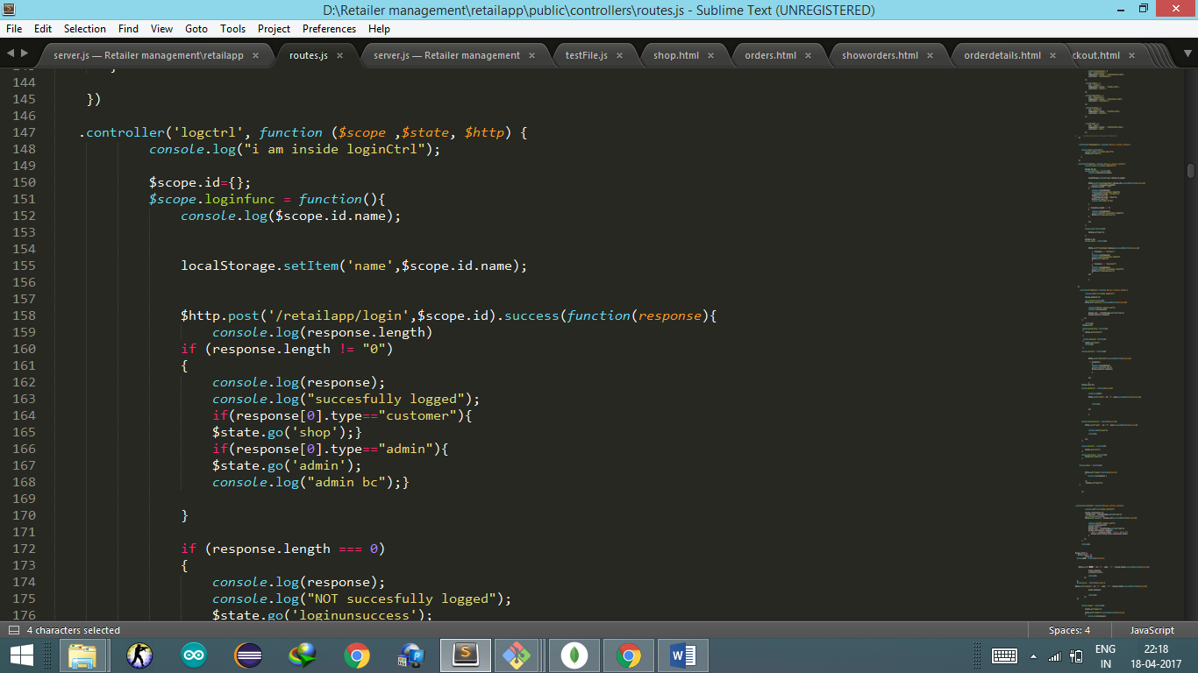

Figure 3: controllers

A Controller is defined by a JavaScript **constructor function** that is used to augment the AngularJS Scope.

Use controllers to:

* Set up the initial state of the $scope object.
* Add behaviour to the $scope object.

Above is an example of defining a controller.

There are the basing coding requirements HTML code are available in this link:

MongoDB storing Format

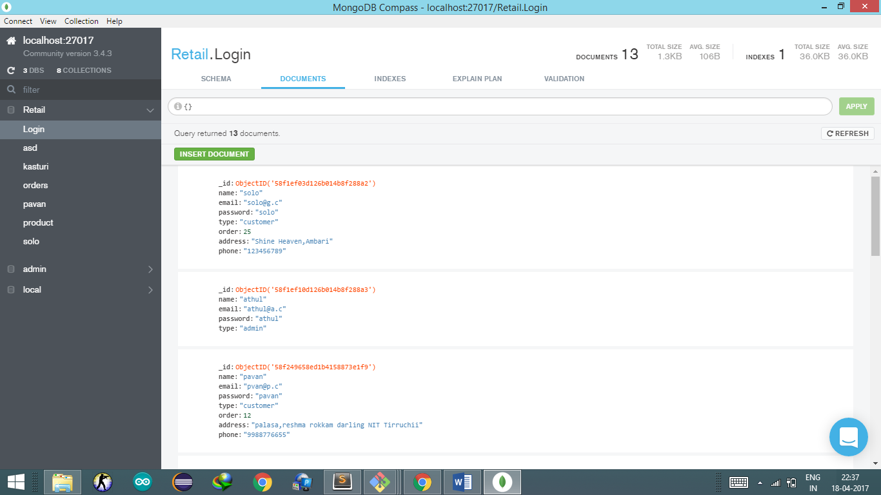

**Application (Screenshots)**

Login

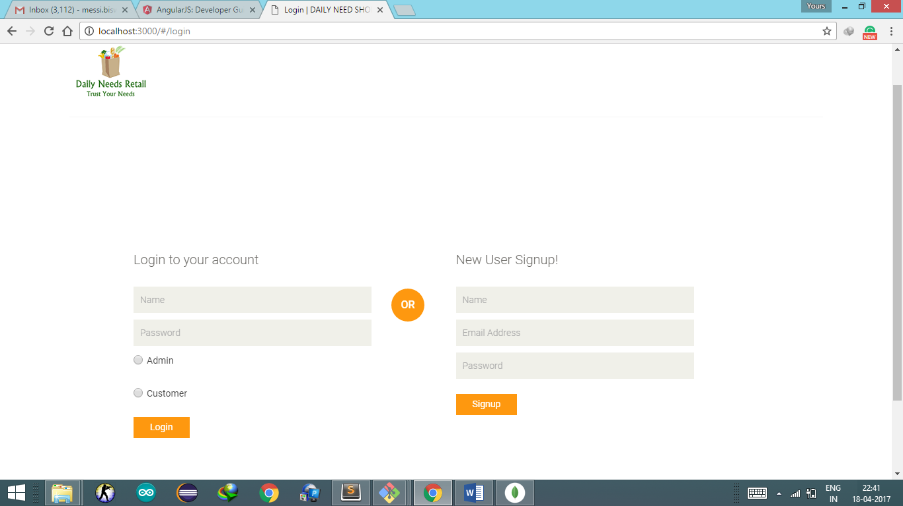

User is allowed to Login using name and password and selecting the option of category they belong to i.e. admin or customer.

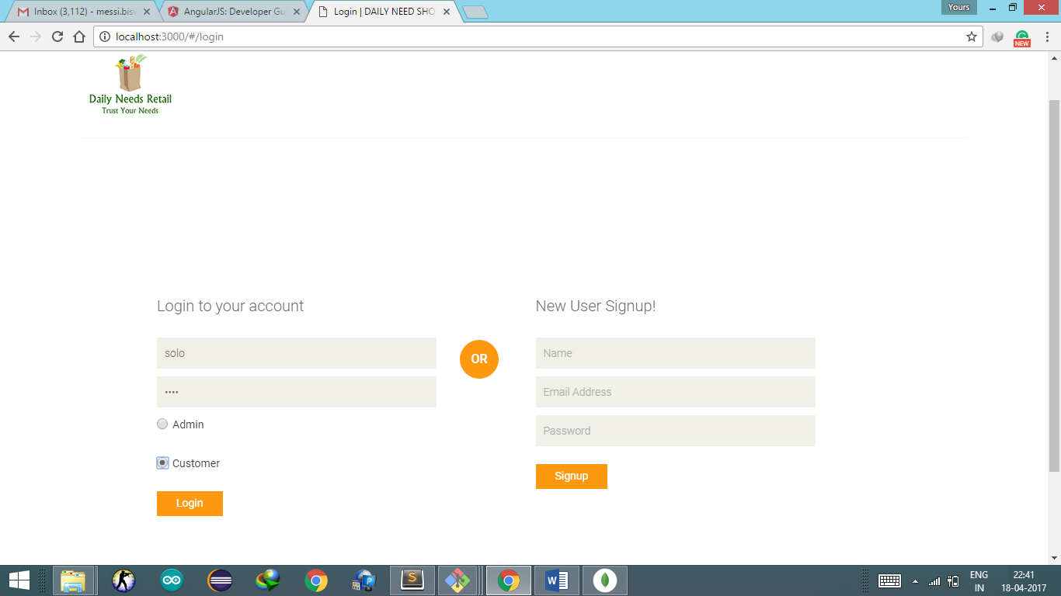

If it does not match it redirects to a retry page.

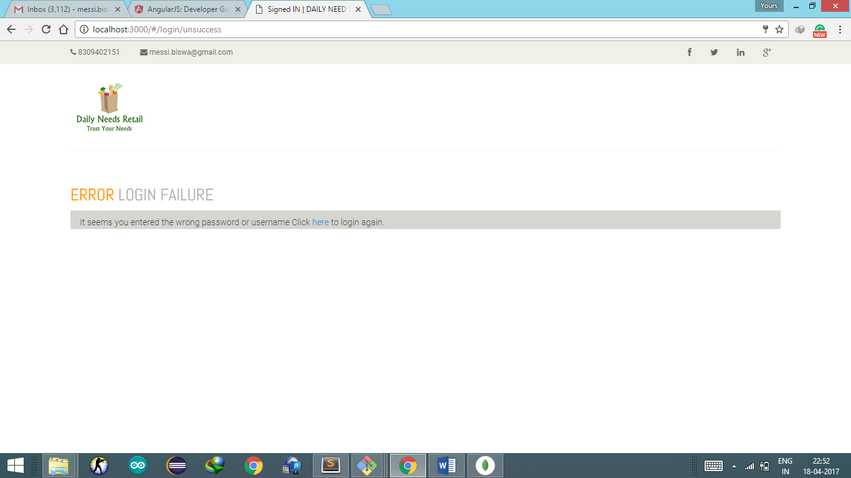

If it matches then it will be redirected to shop page.

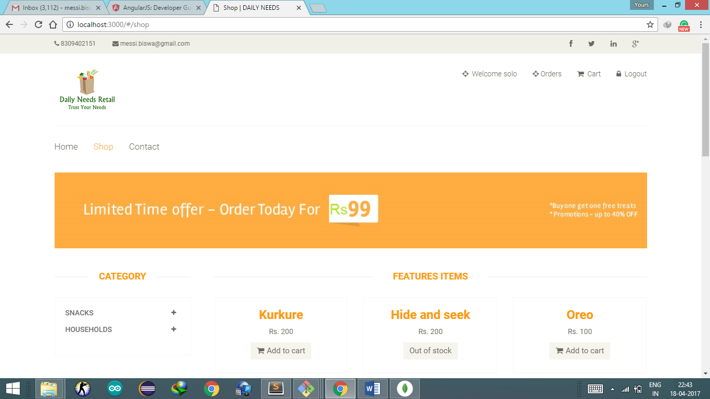

This is the shop page where the products are being displayed

The user has the options to

* See profile
* See orders
* Go to cart
* Or Logout

User can add products to cart by clicking add to cart

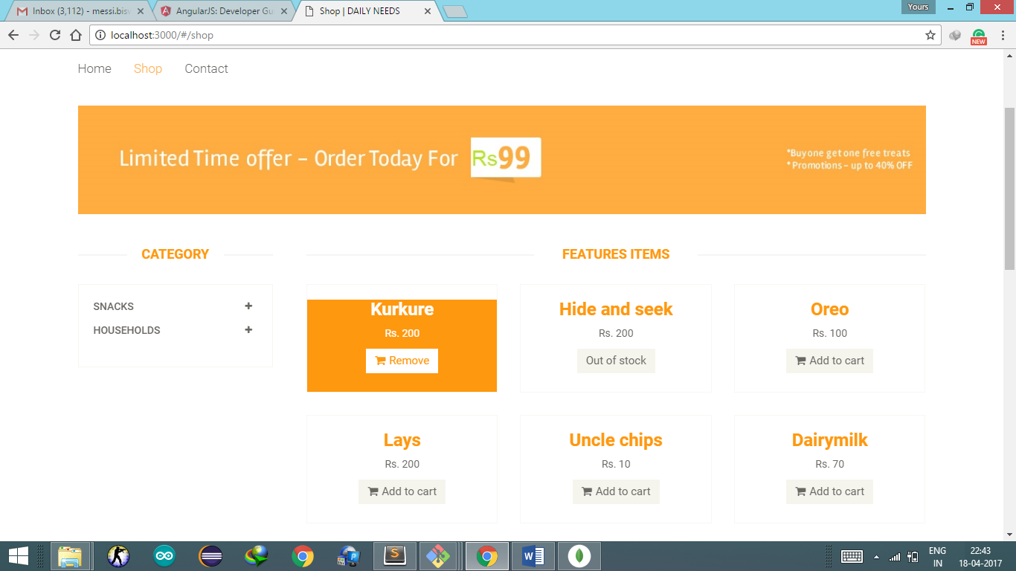

Or can remove it by clicking Remove

The products which are having stock value 0 are not allowed to be added to cart.

See Profile

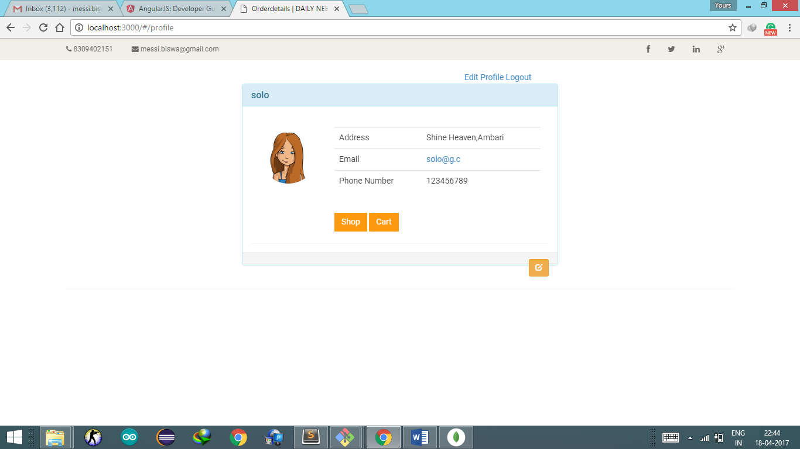

User can see its profile having the information about the address and phone number

And can edit it accordingly.

Edit profile

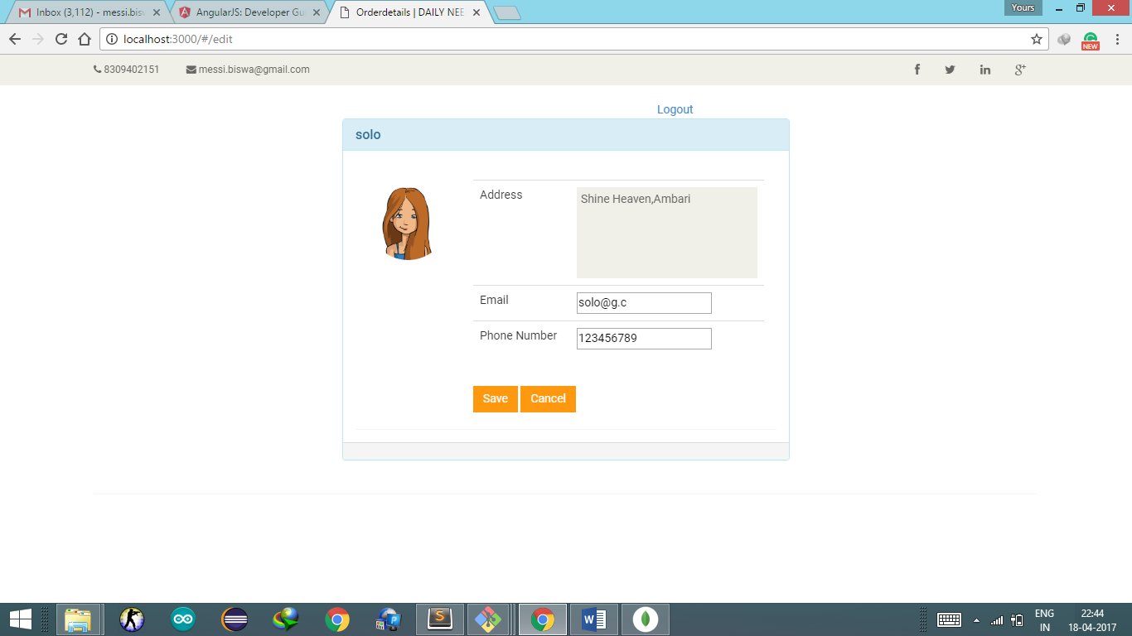

The address has been changed.

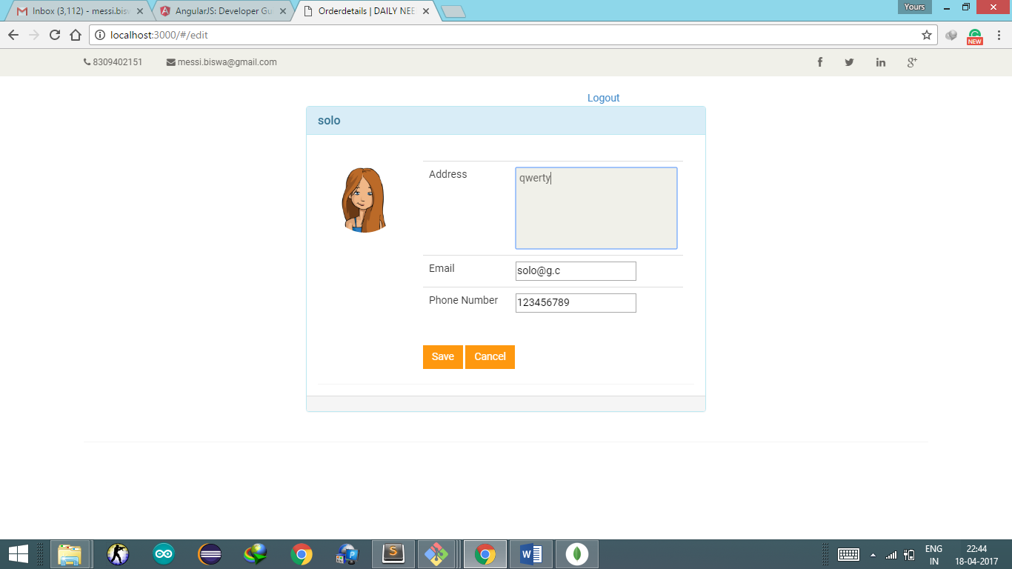

And Saved So the Profile now is-

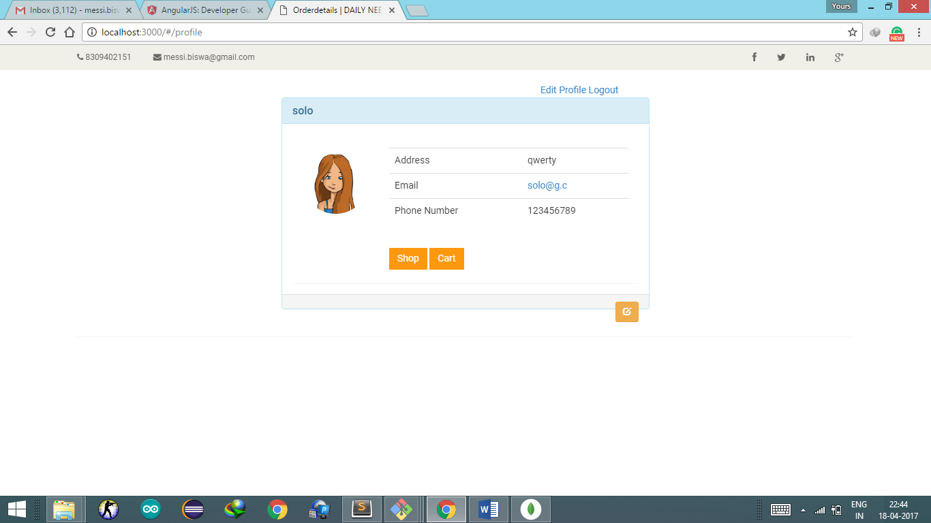

See Orders

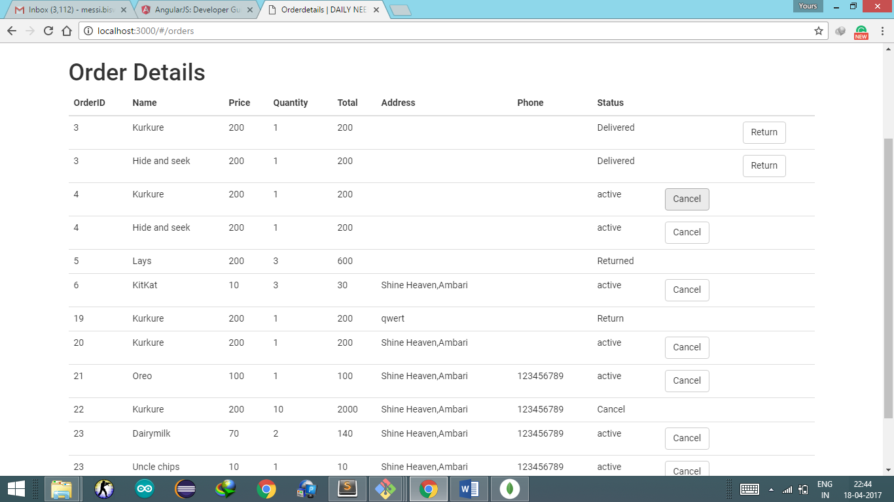

This gives the List of previous Orders with their status.

One can cancel the order with status “active”

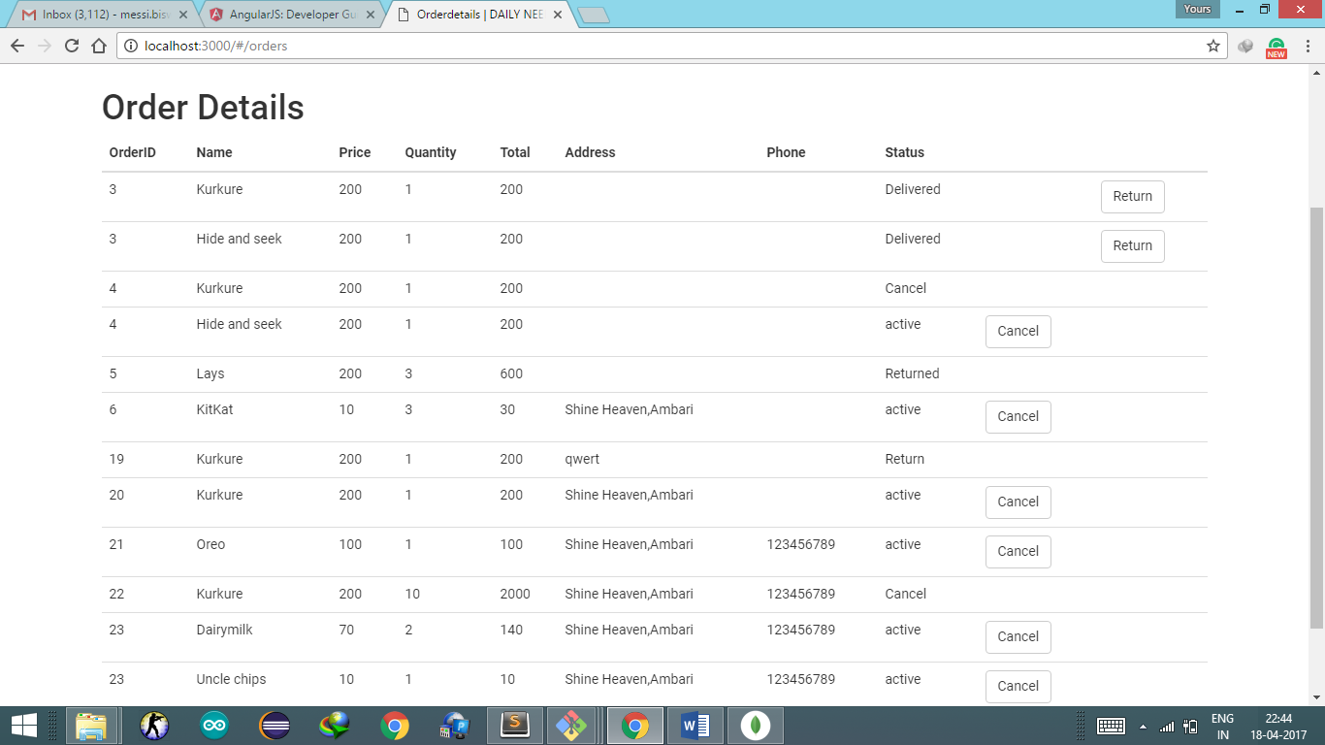

One can return the product by changing the status in to “Delivered” to “Return”

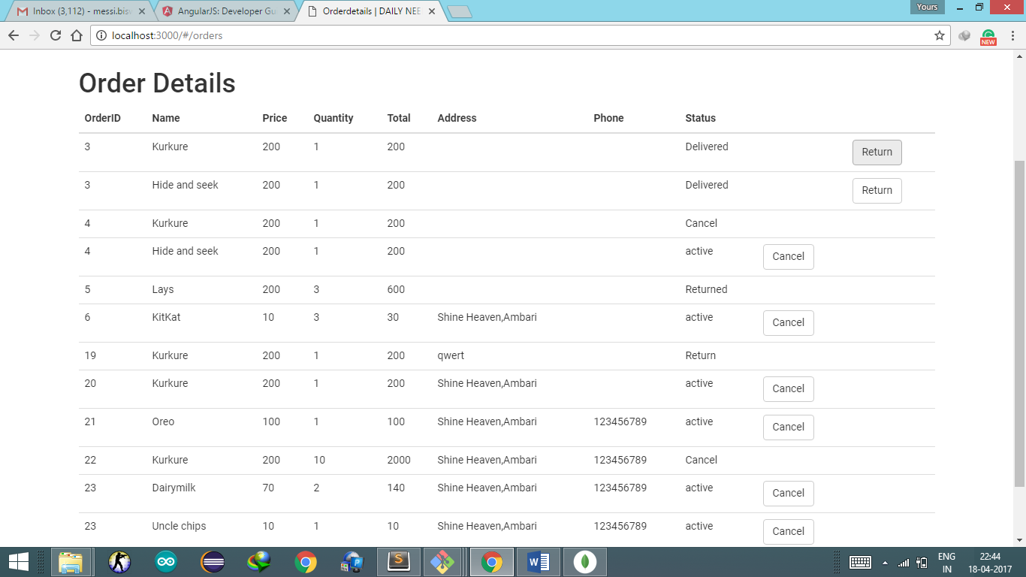

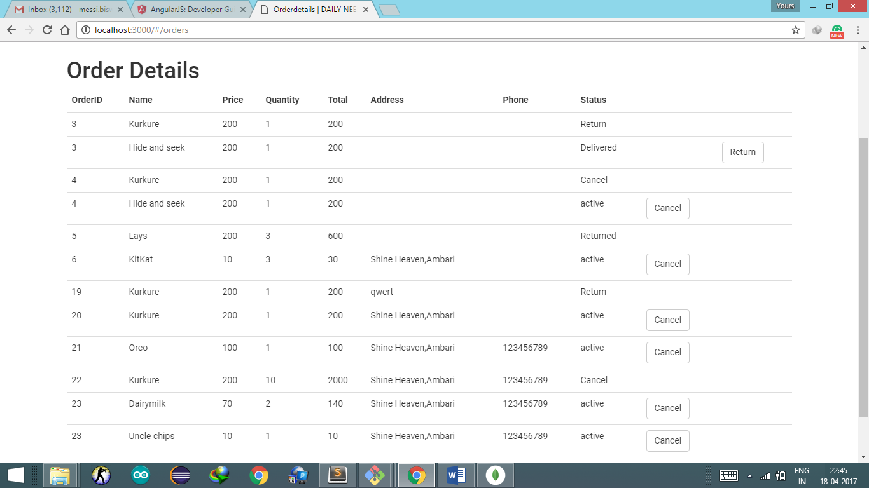

Go to Cart

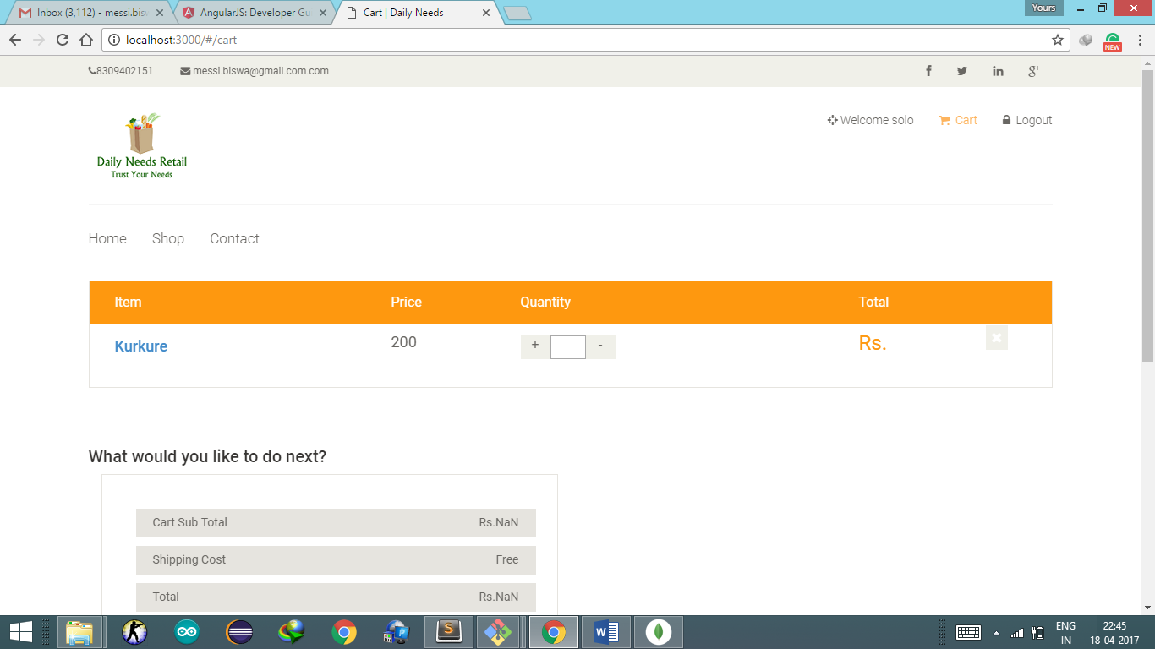

Added Product is displayed

One can add quantity or can reduce it

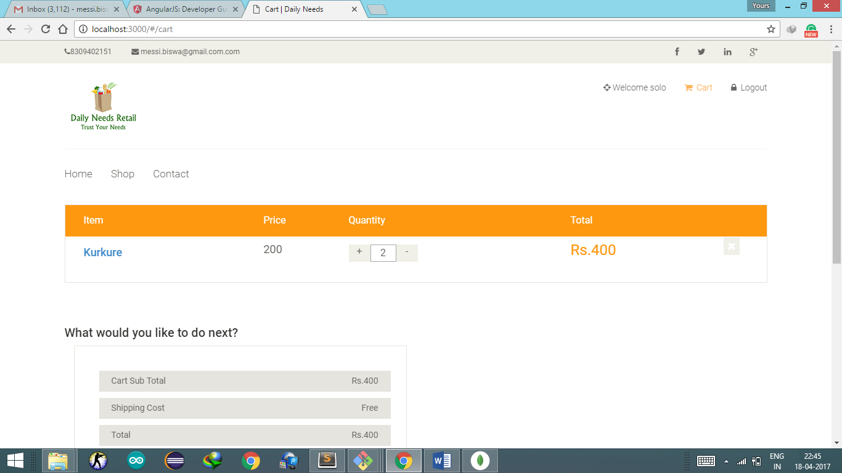

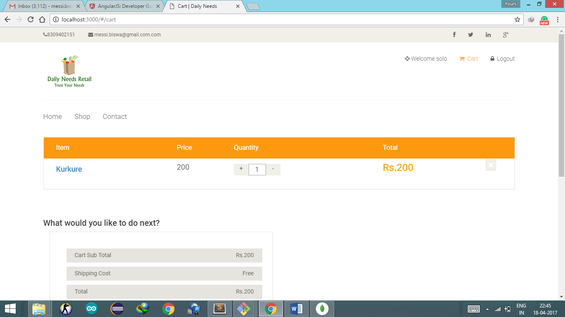

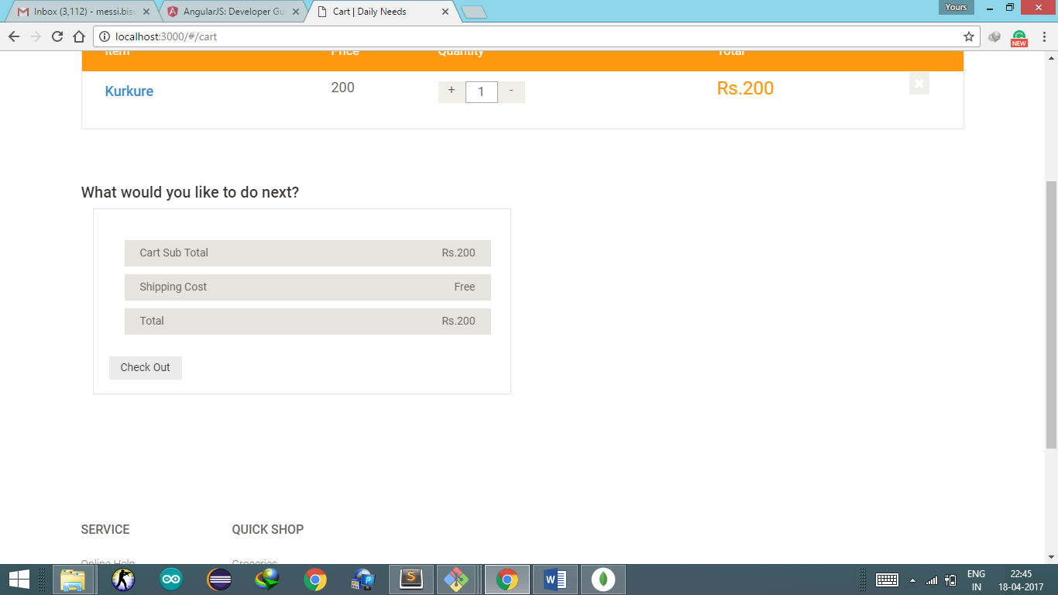

After Adding One can to to shop and add some more product orr can checkout

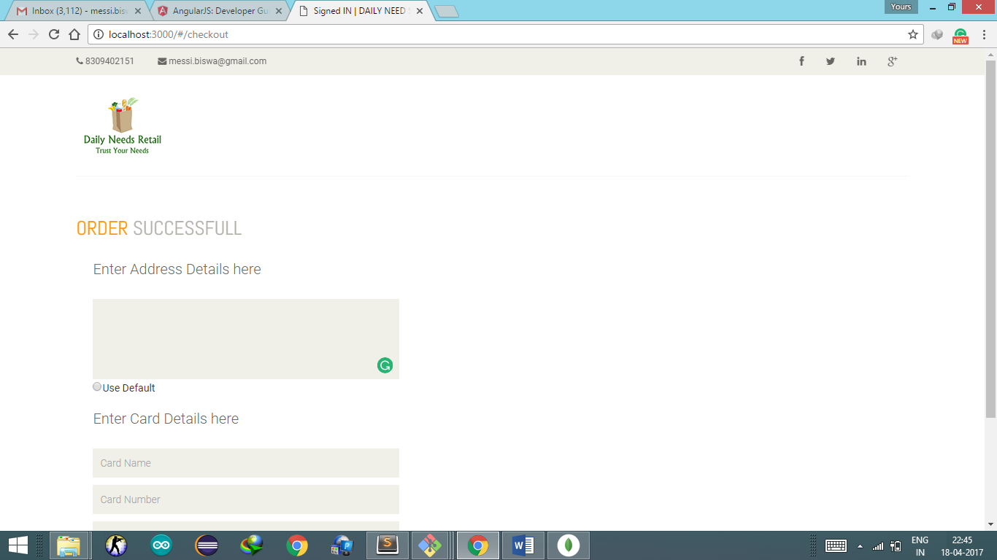

After filling the address and card details one can confirm and pay or can cancel

Also one can use the default address present in the profile

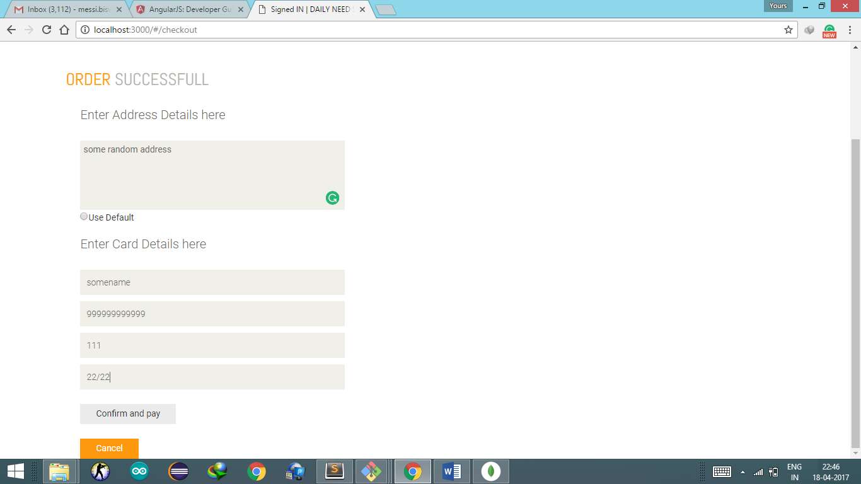

After check out the order detail(Bill) is displayed.

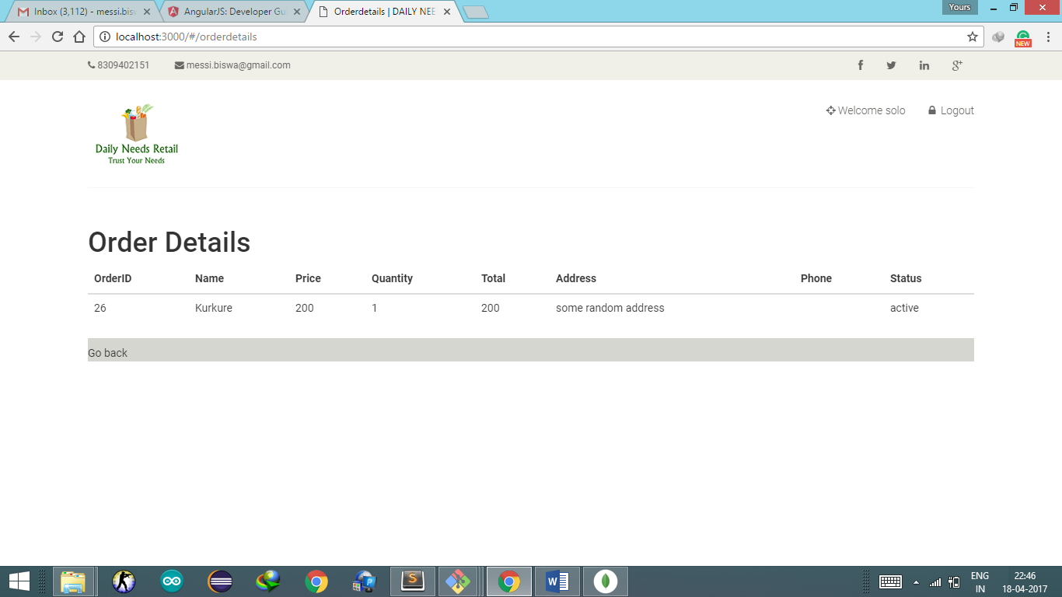

One can go back and buy more products or can logout

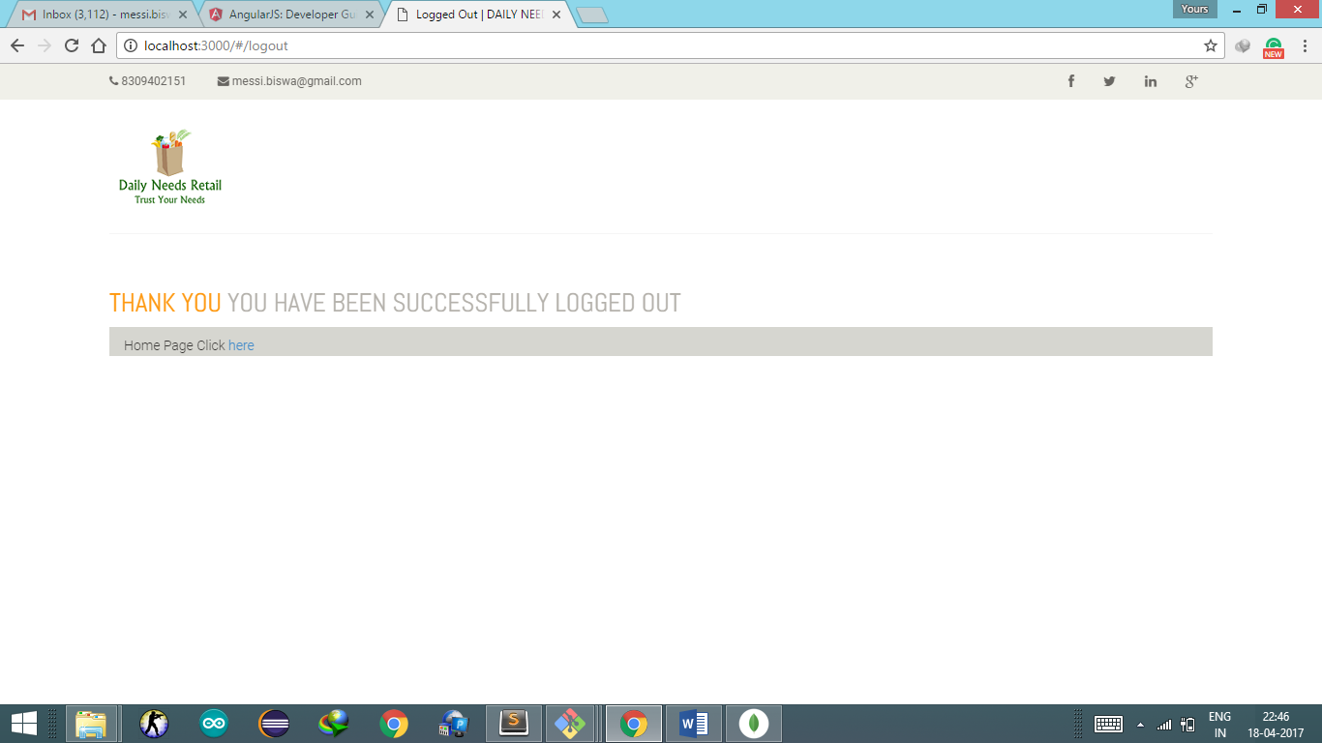

For Admin (Retailer)

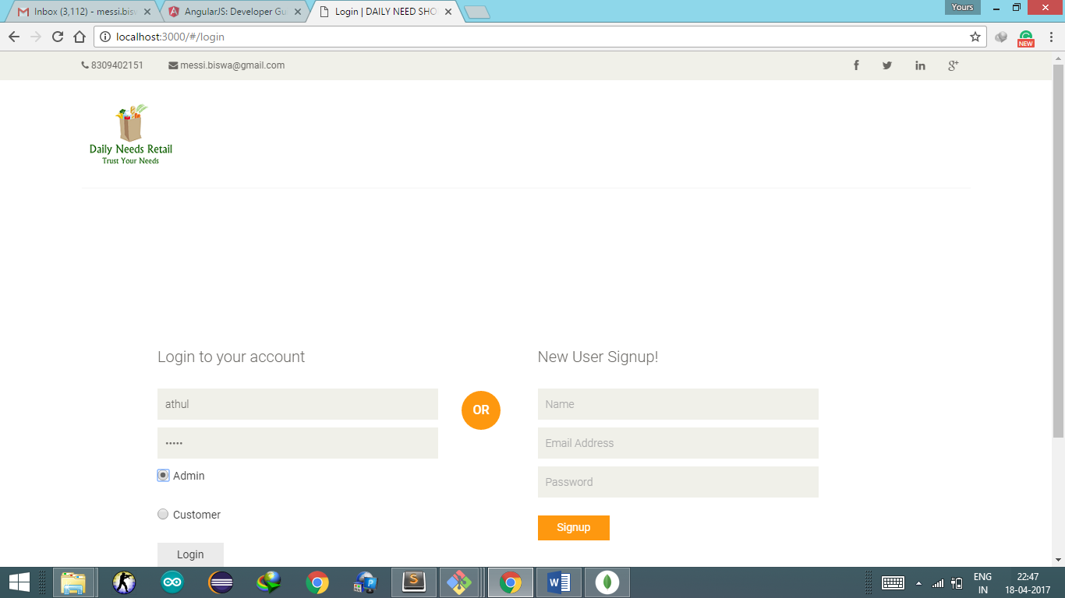

Using its credential admin can login

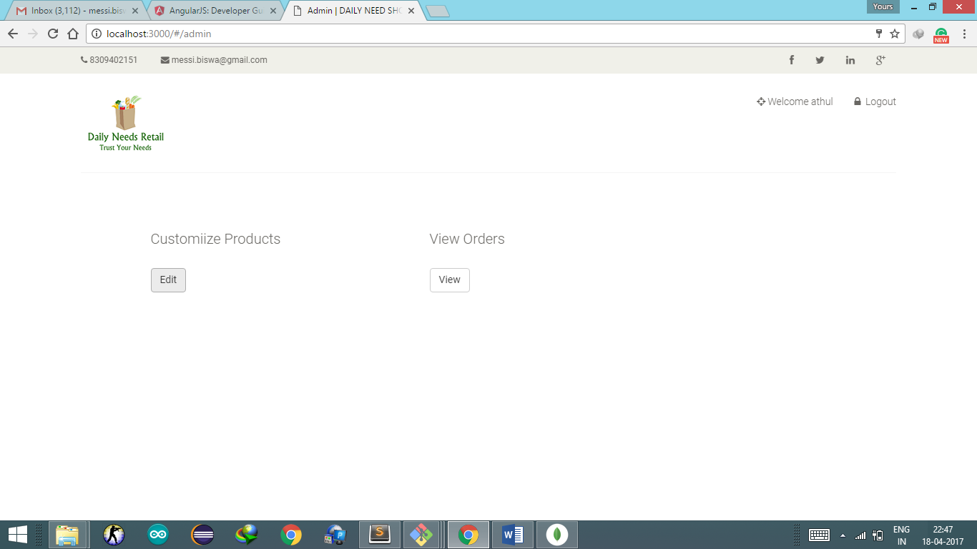

Admin can edit the product details or can view all orders by the customers

Following operations in edit product

Add product

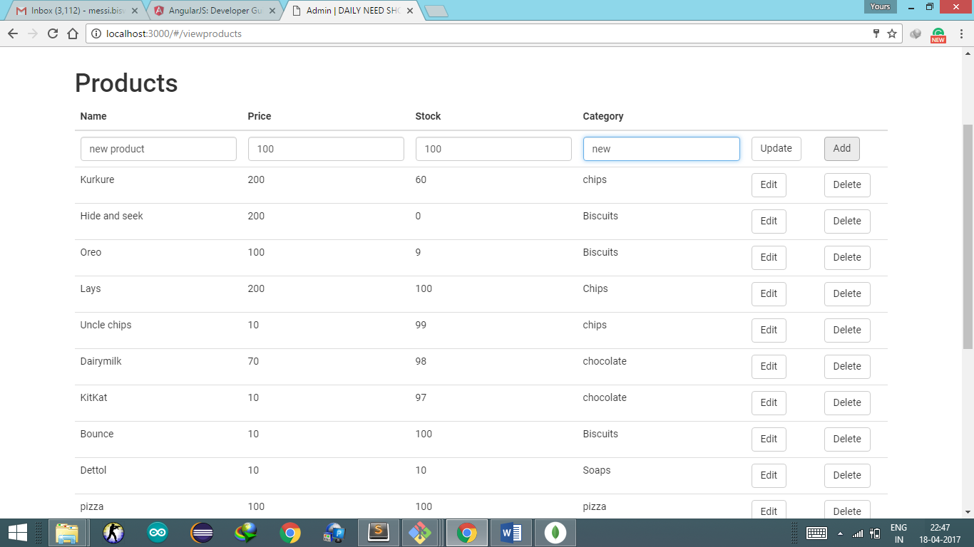

And the added product is displayed in the list.

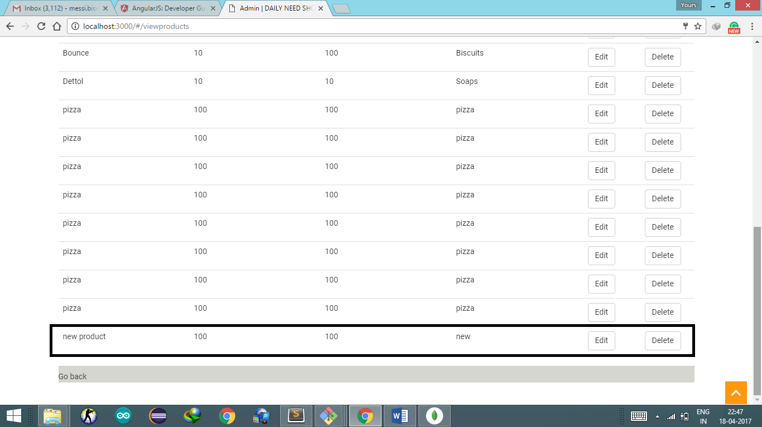

Delete Product

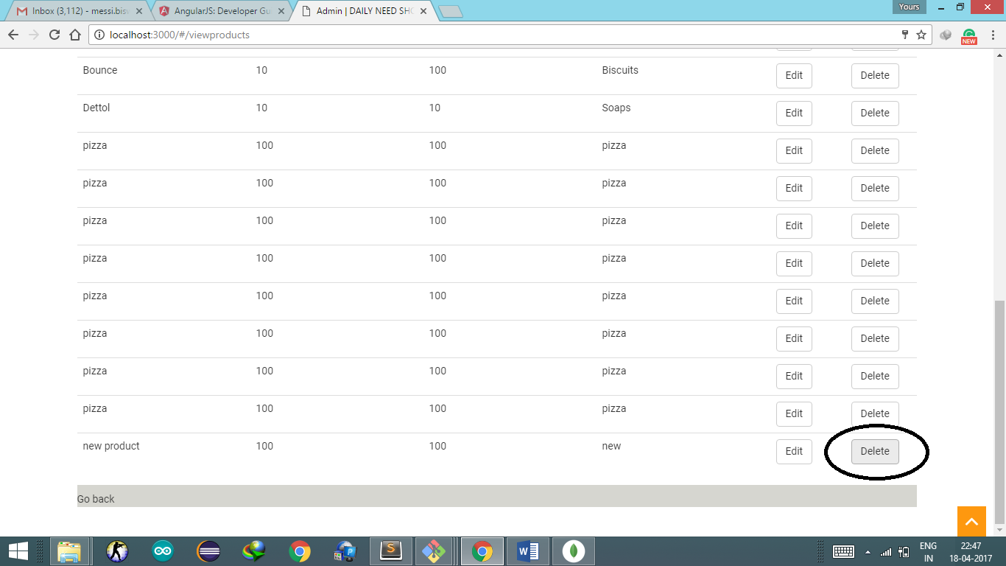

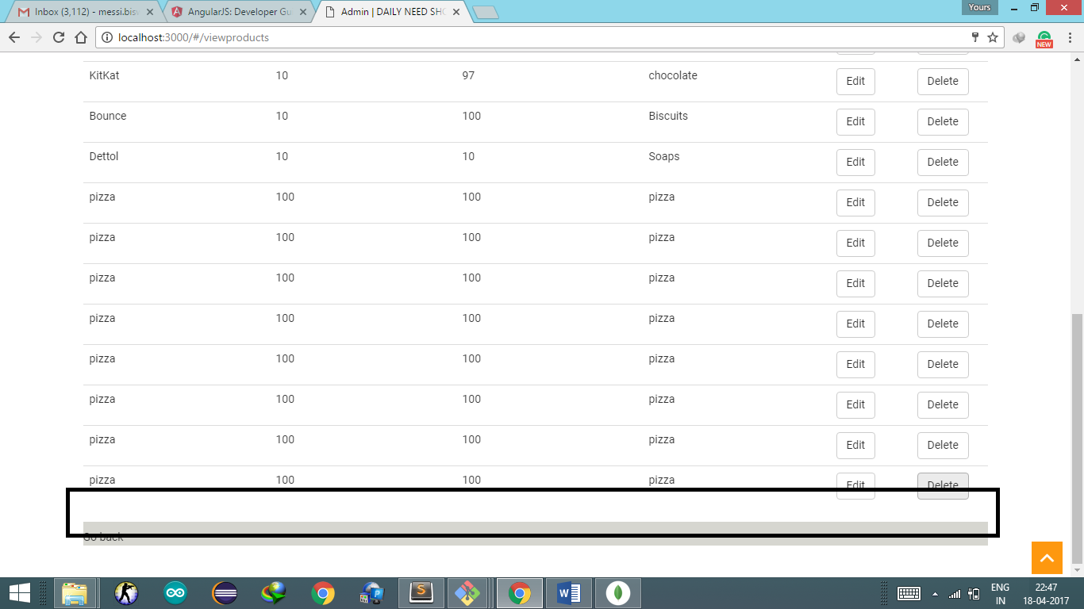

Edit product

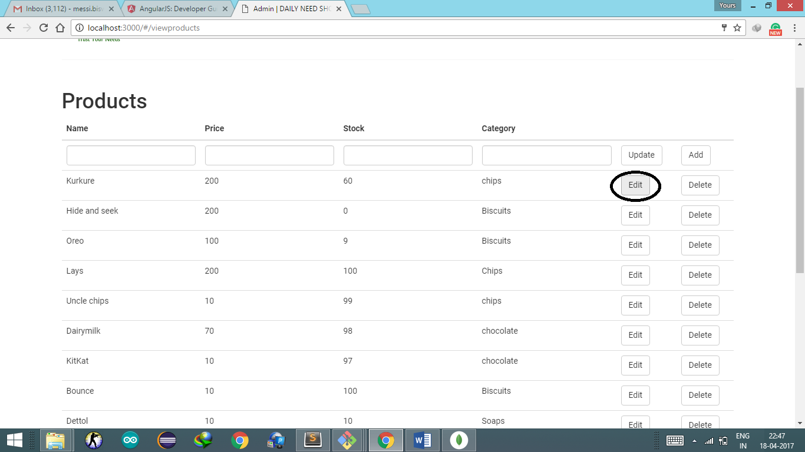

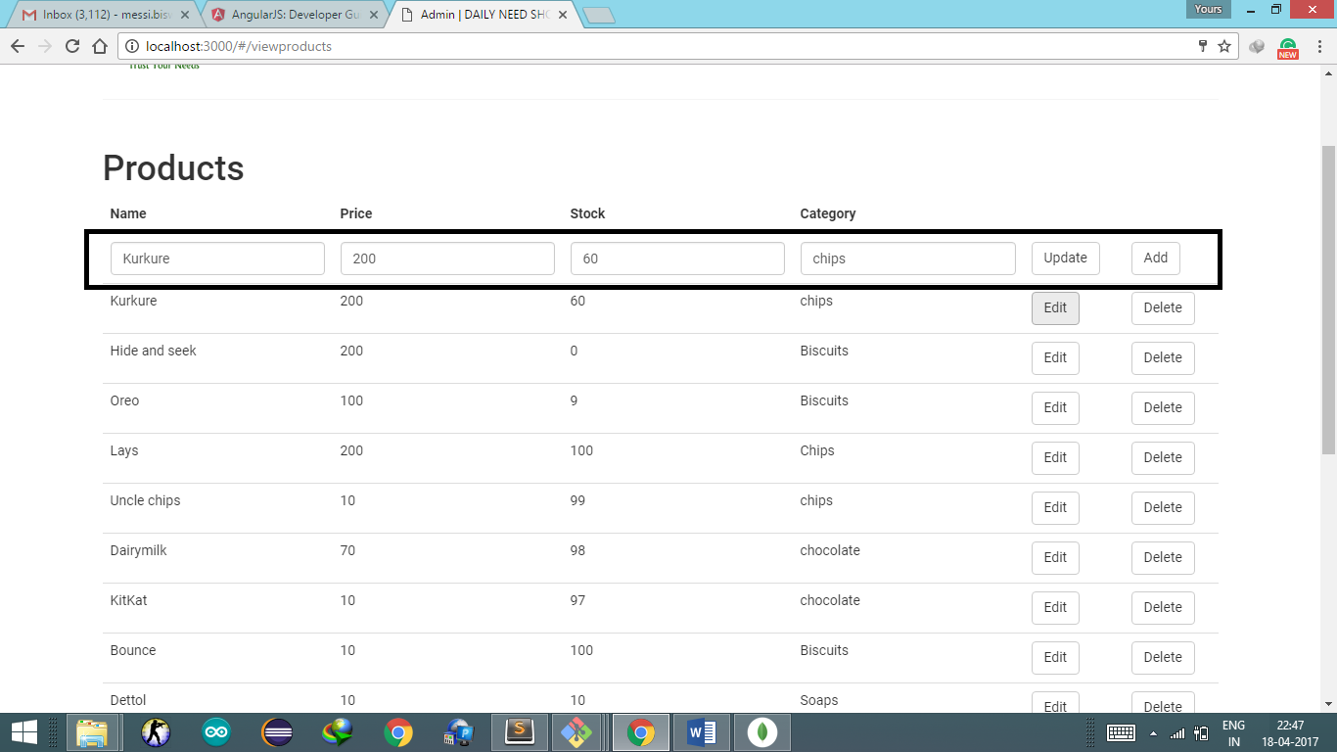

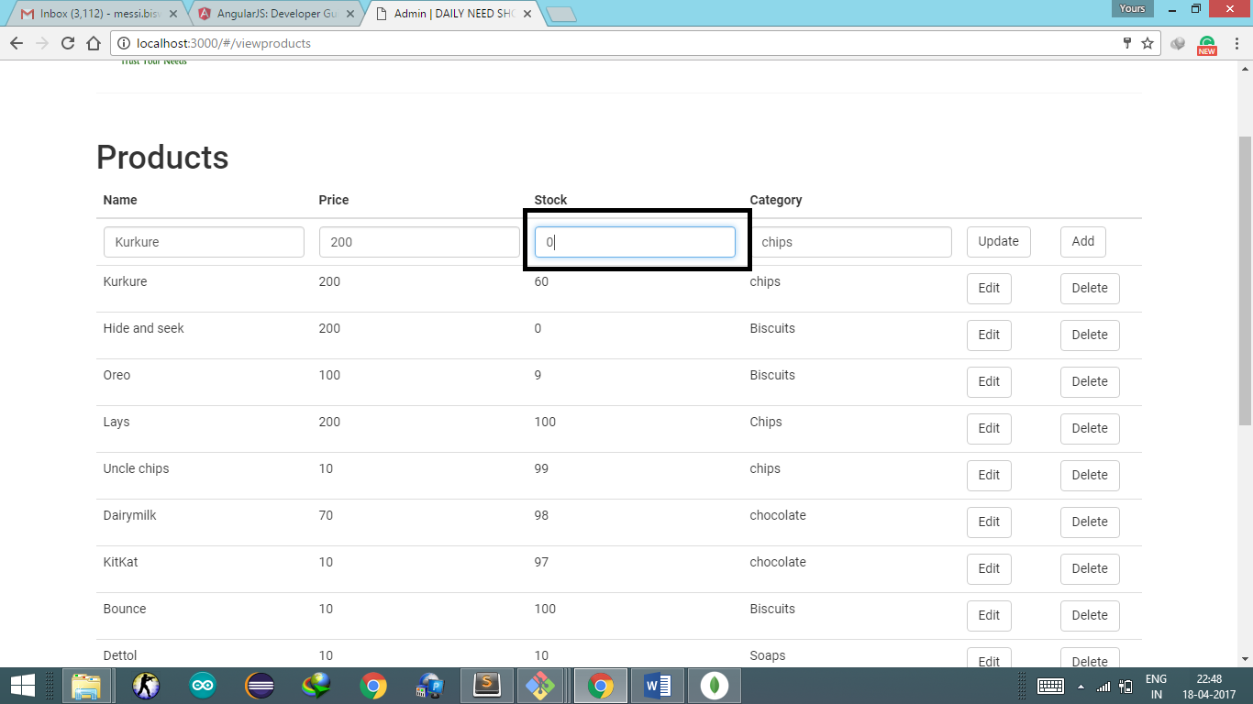

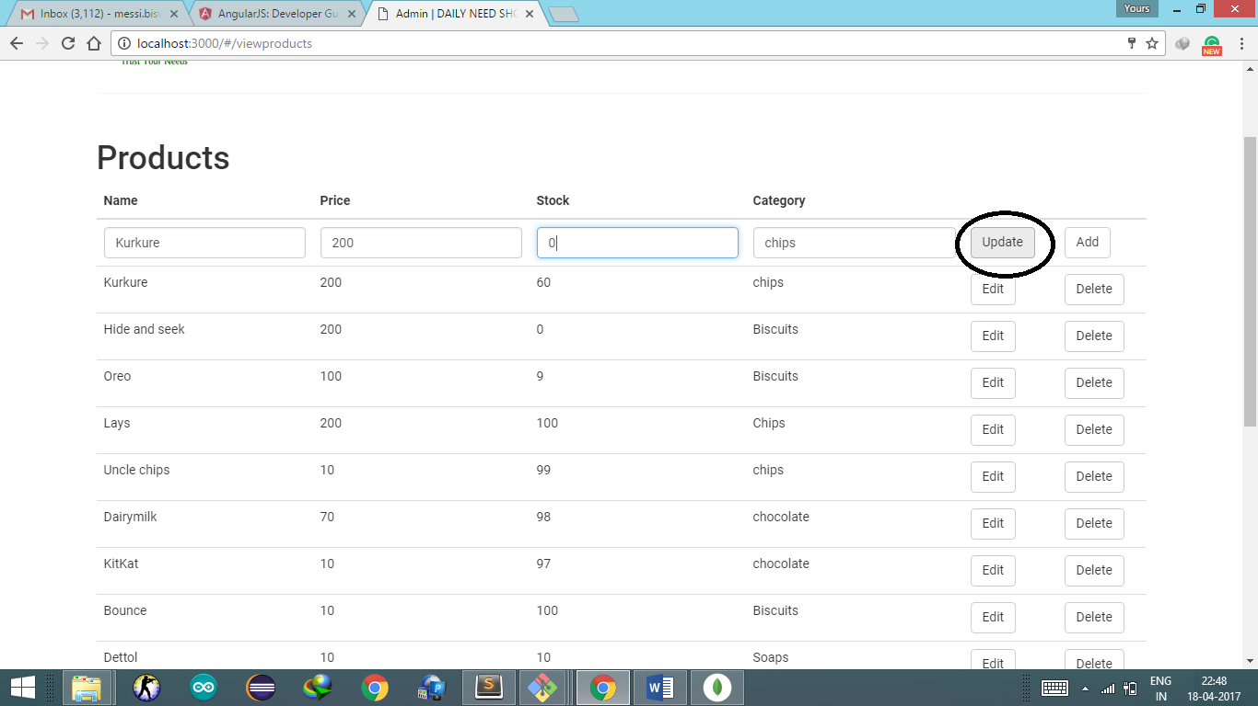

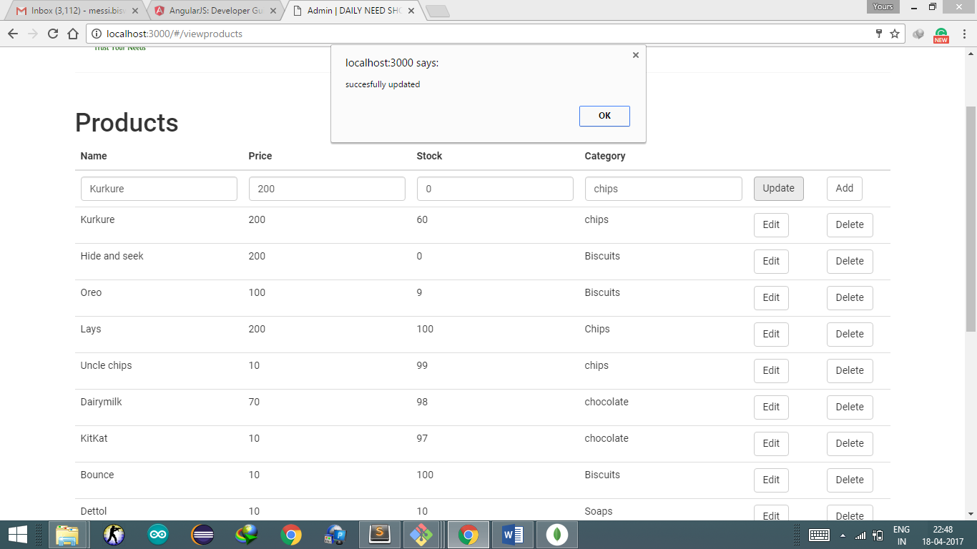

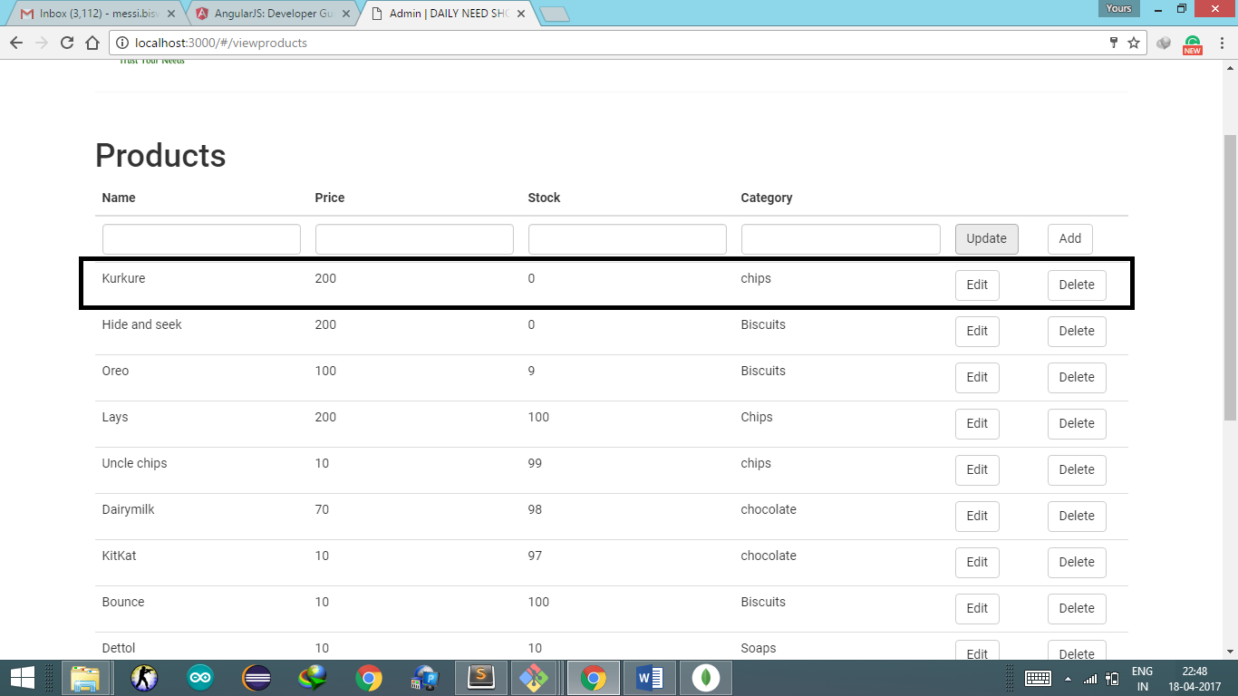

Go back to main menu

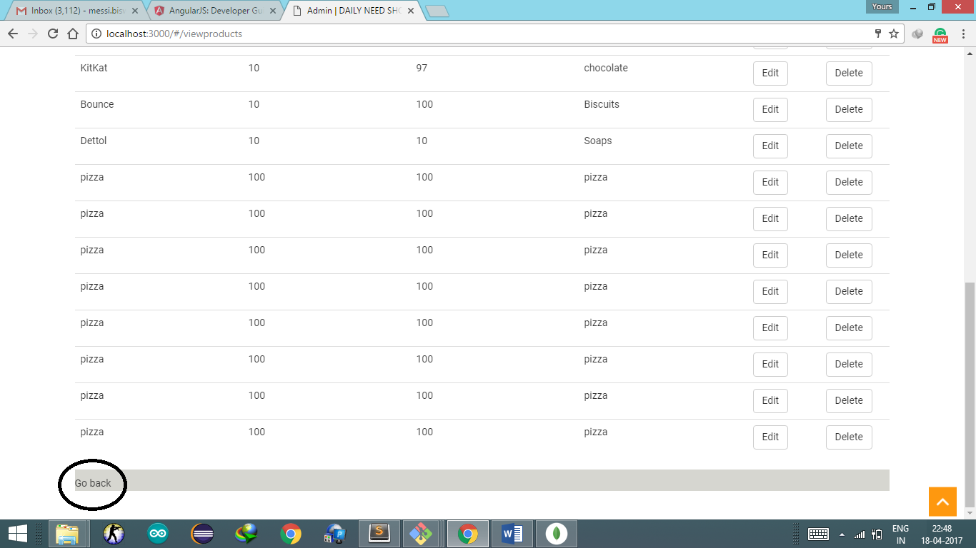

View Orders

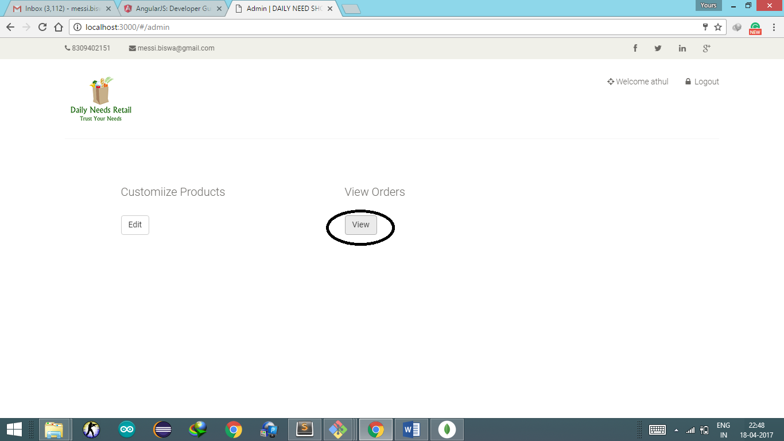

Order Lists

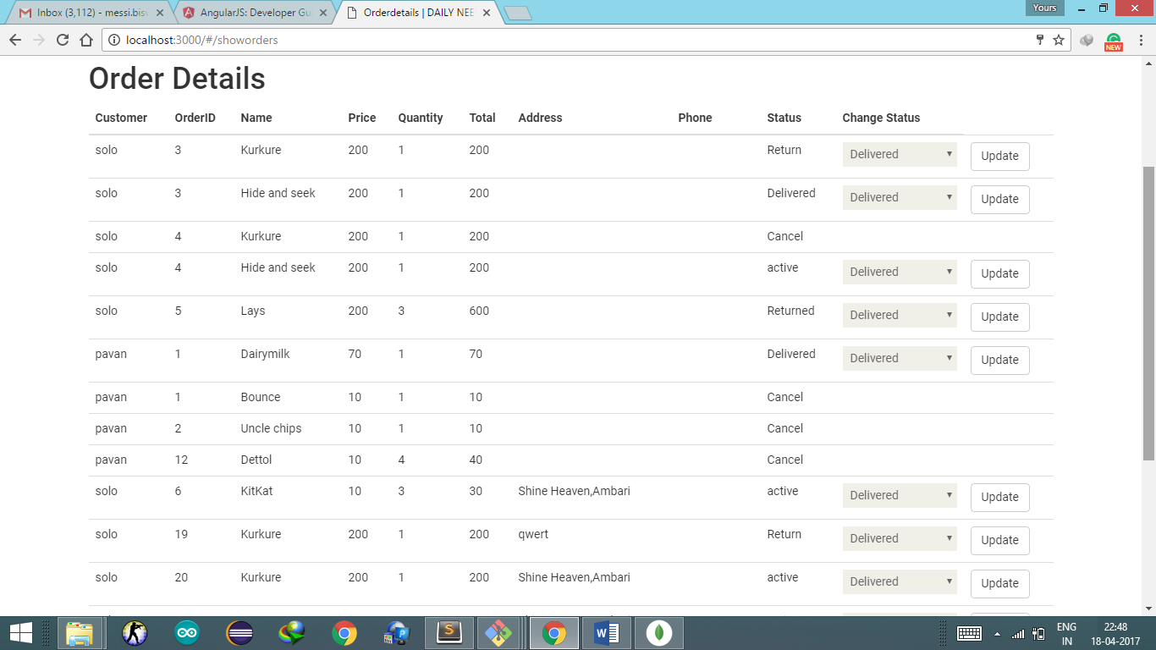

Change Order status

“active” to “Delivered”

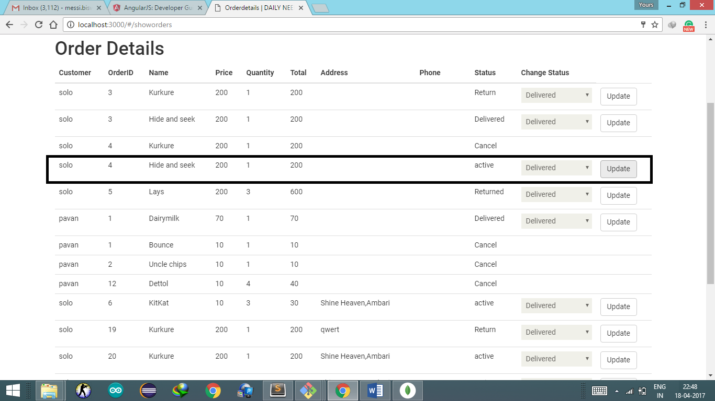

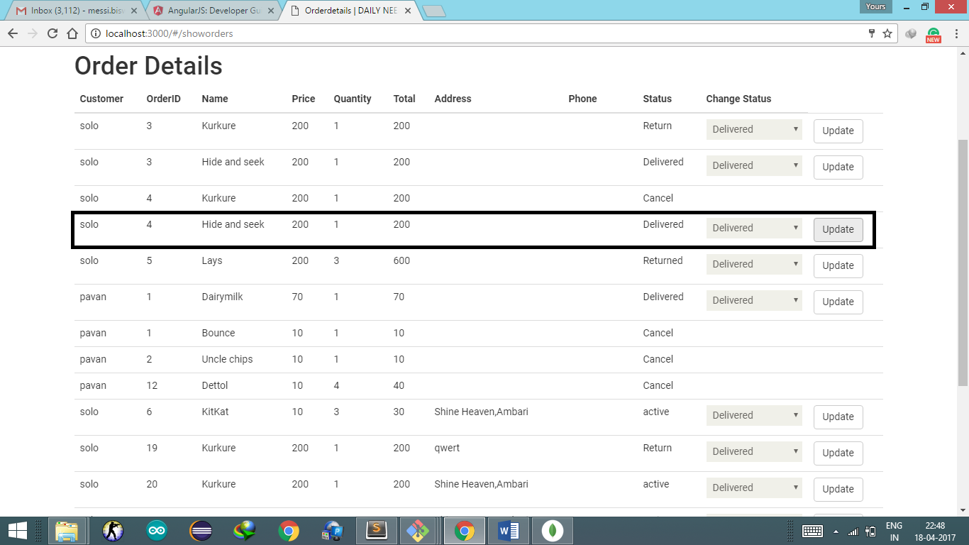

Return to Returned

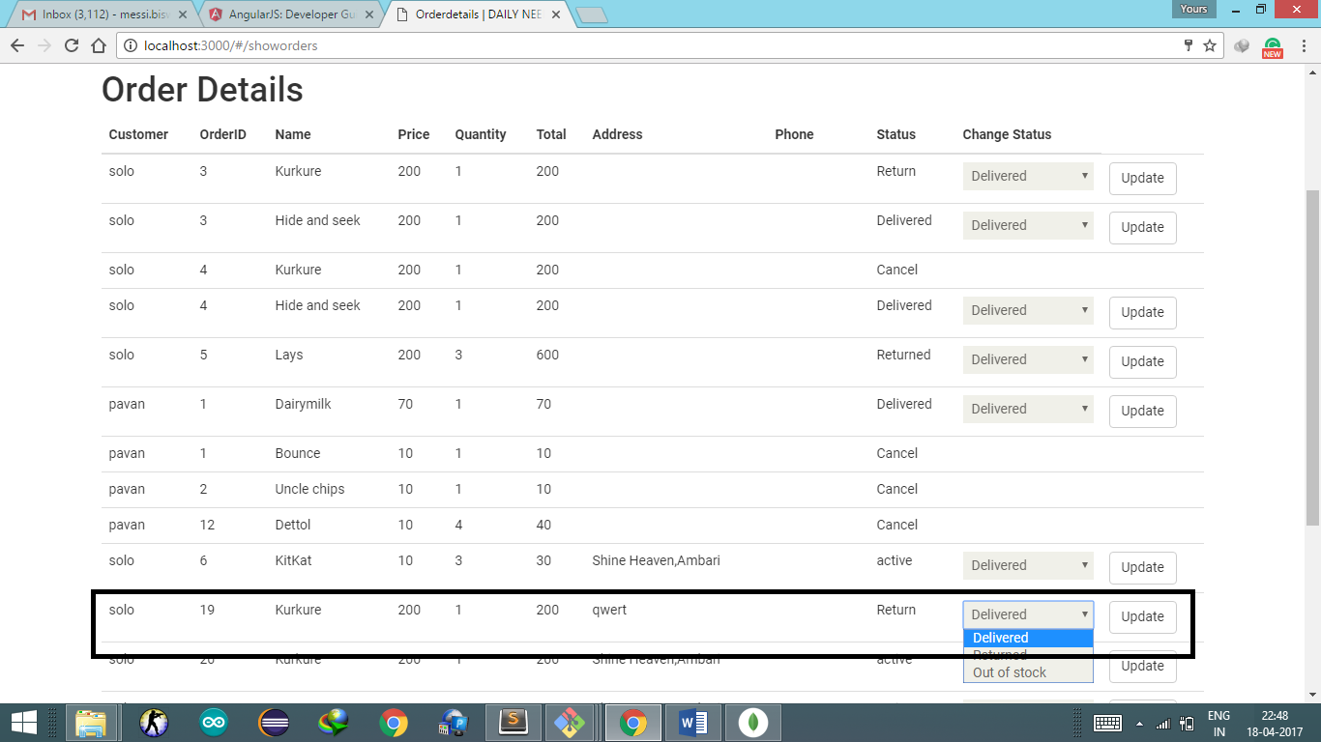

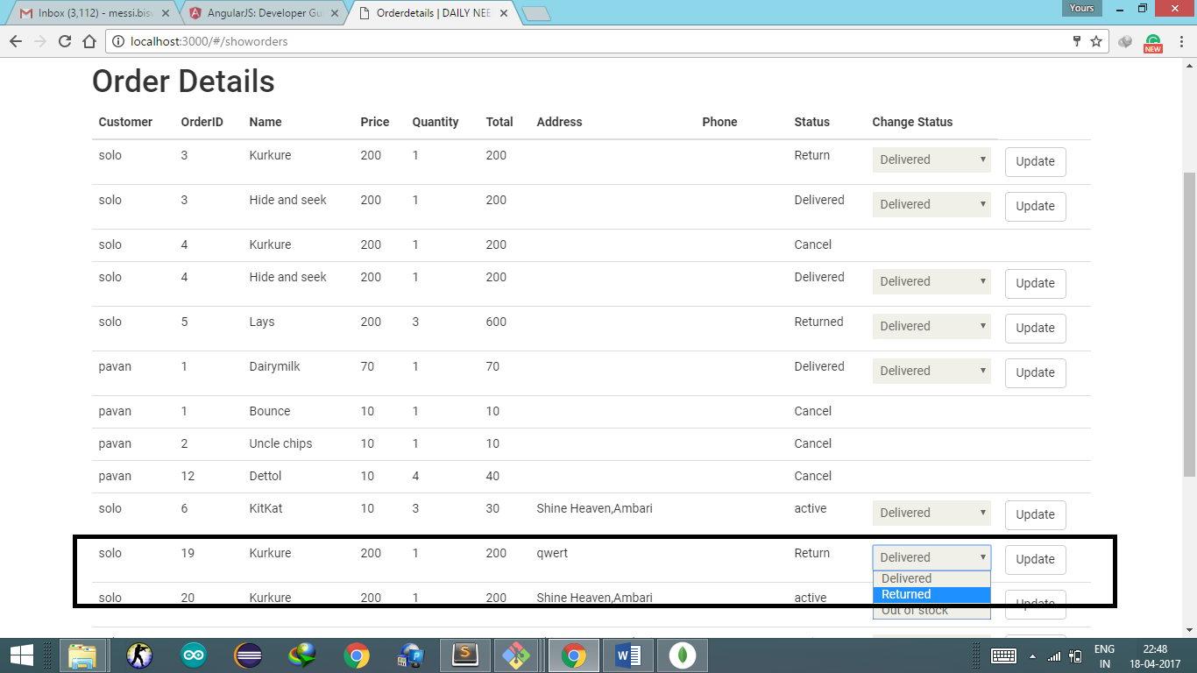

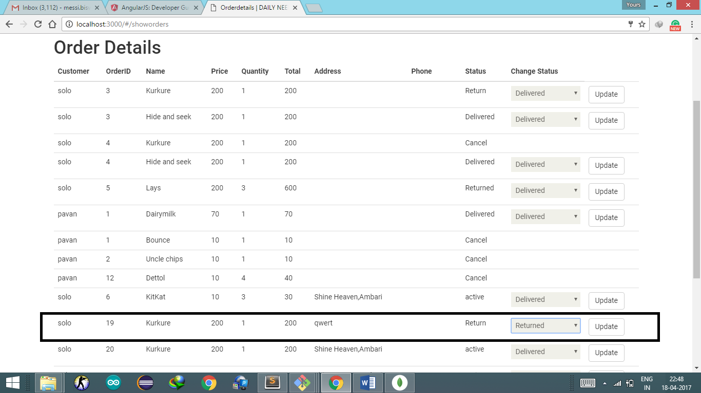

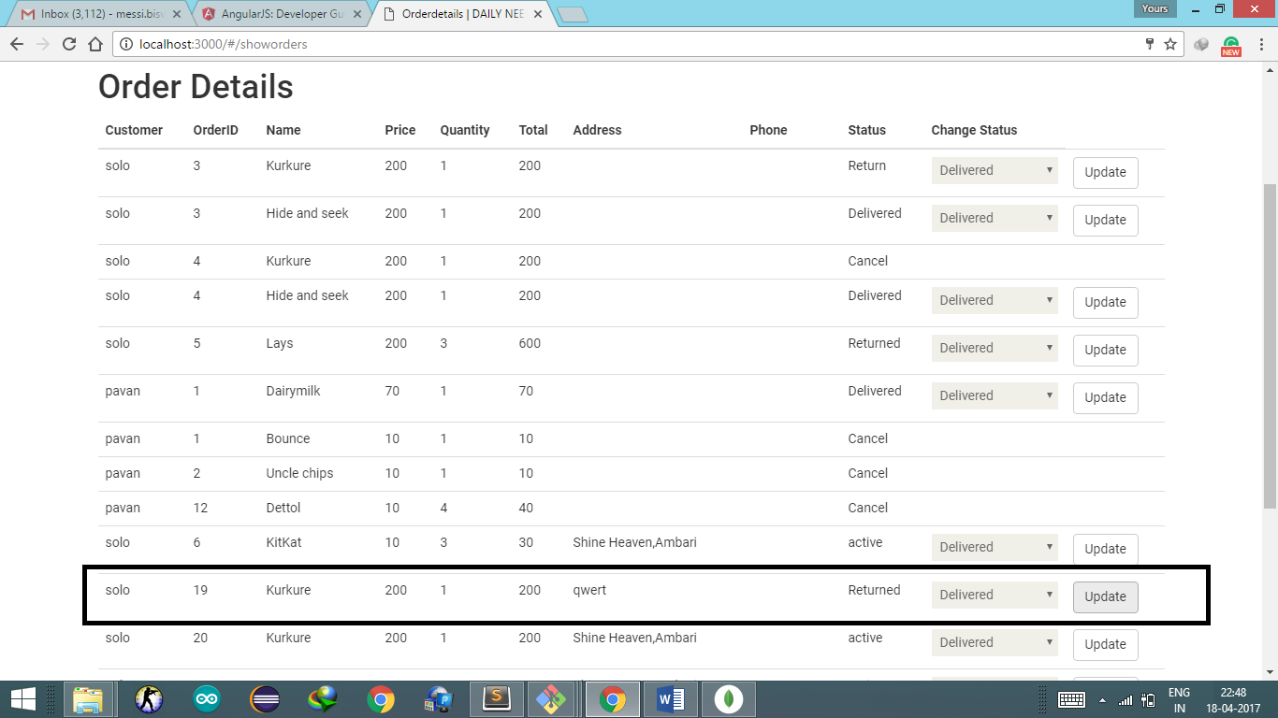

Active to Out of Stock

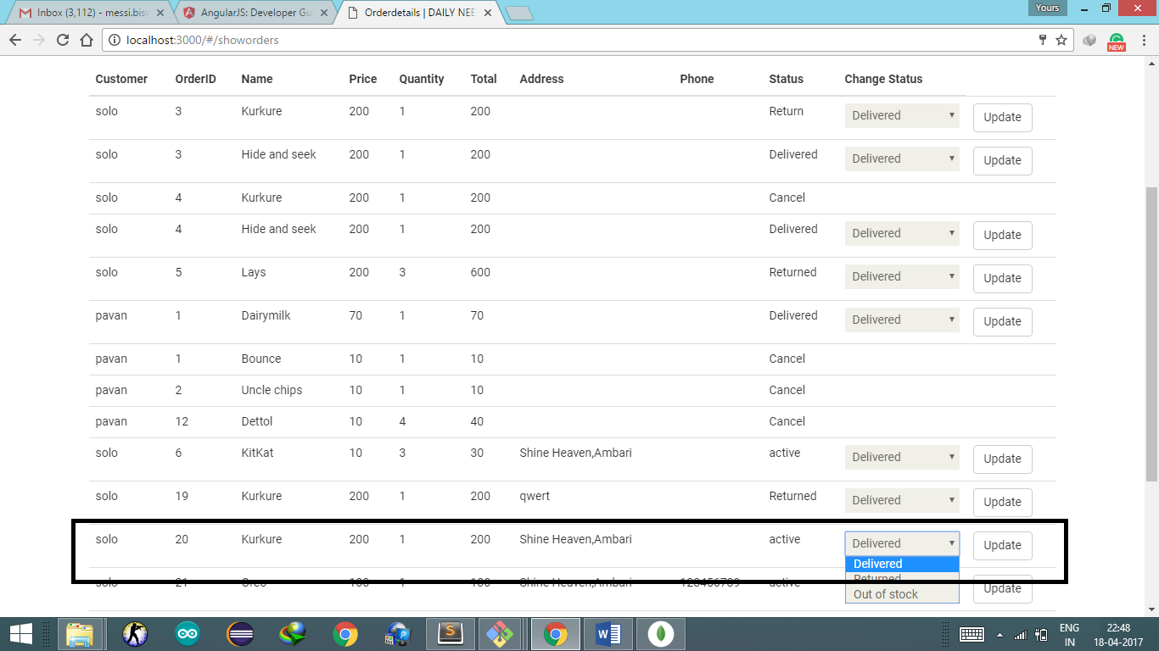

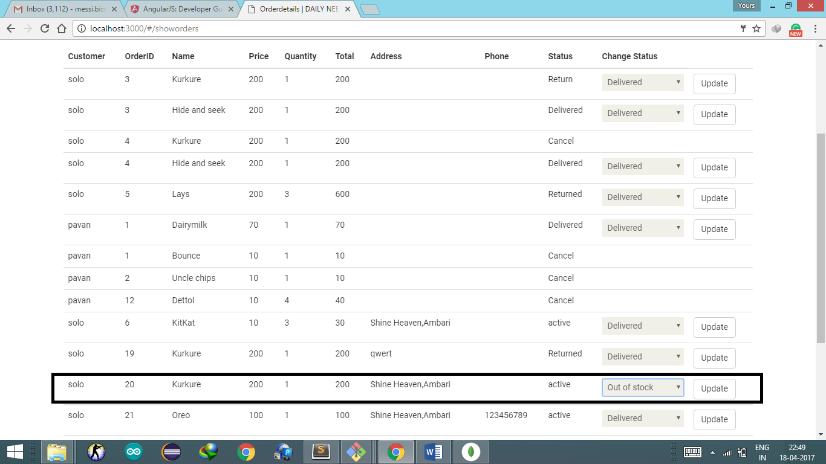

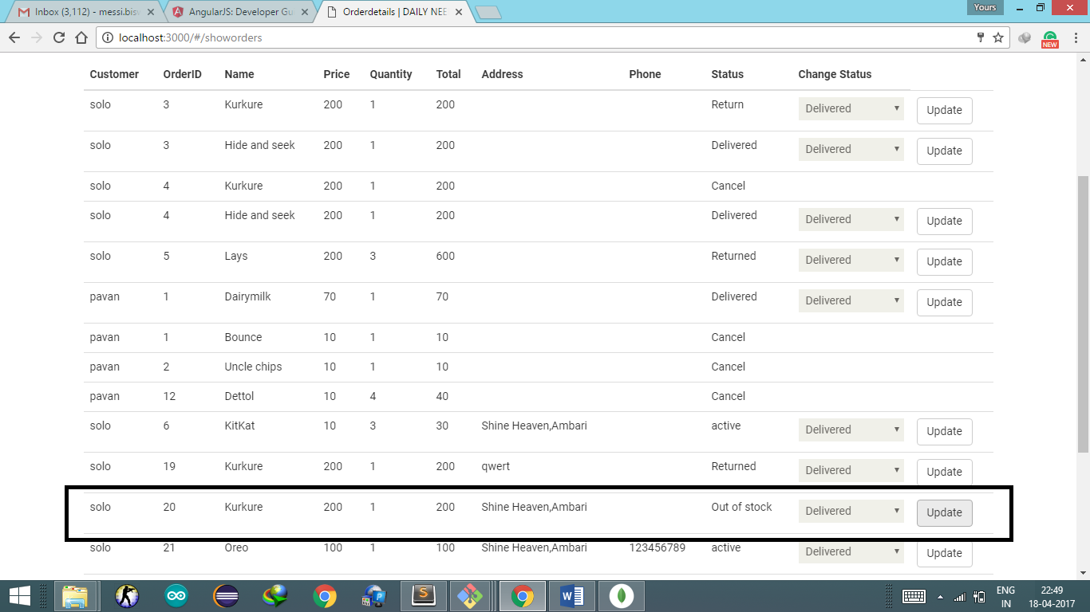

Logout

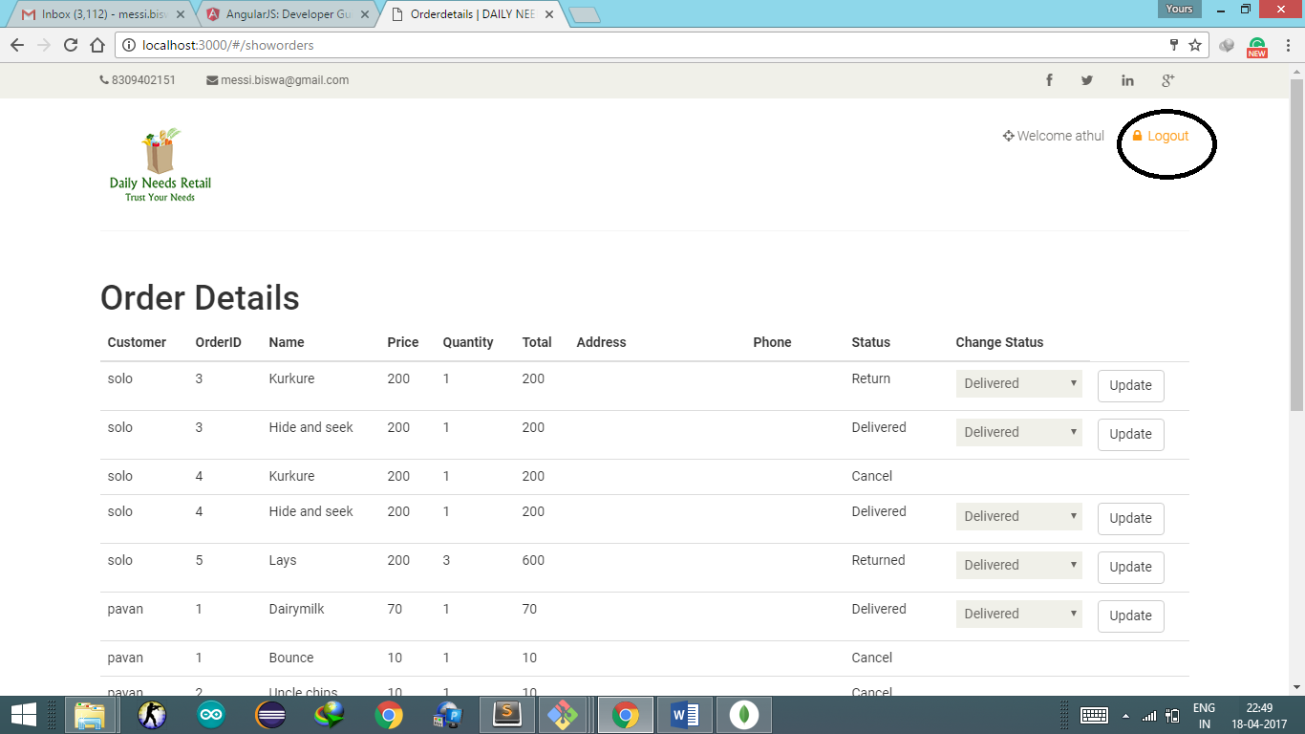

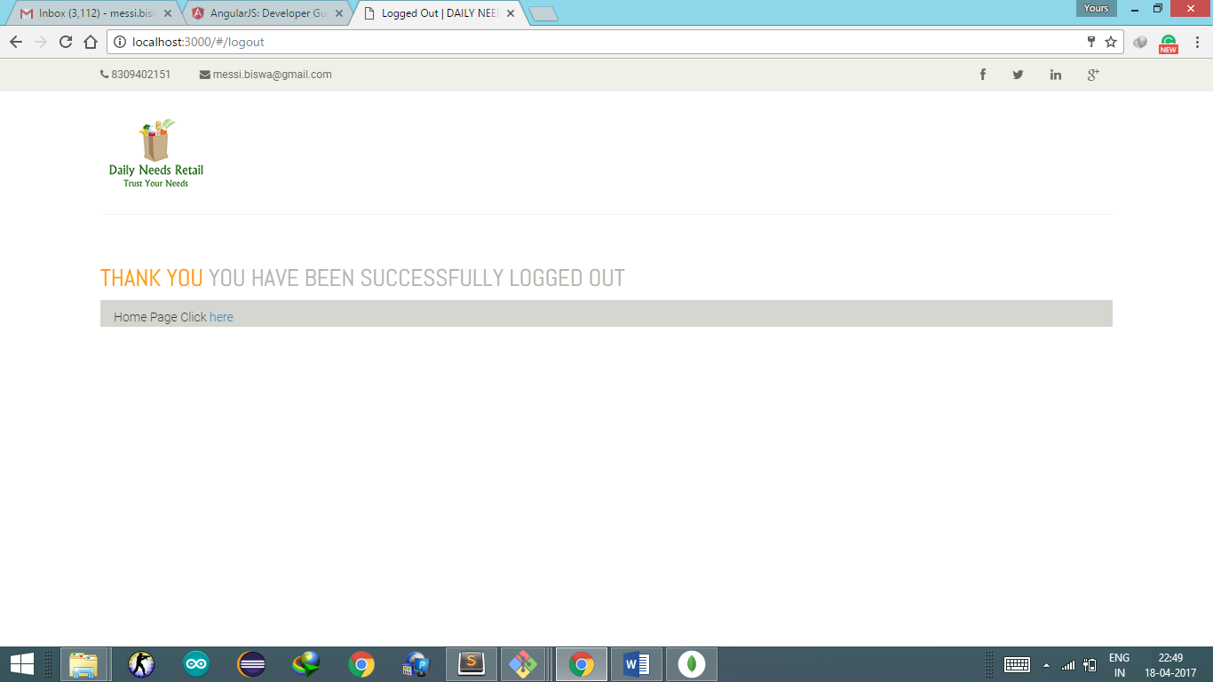

Sign Up

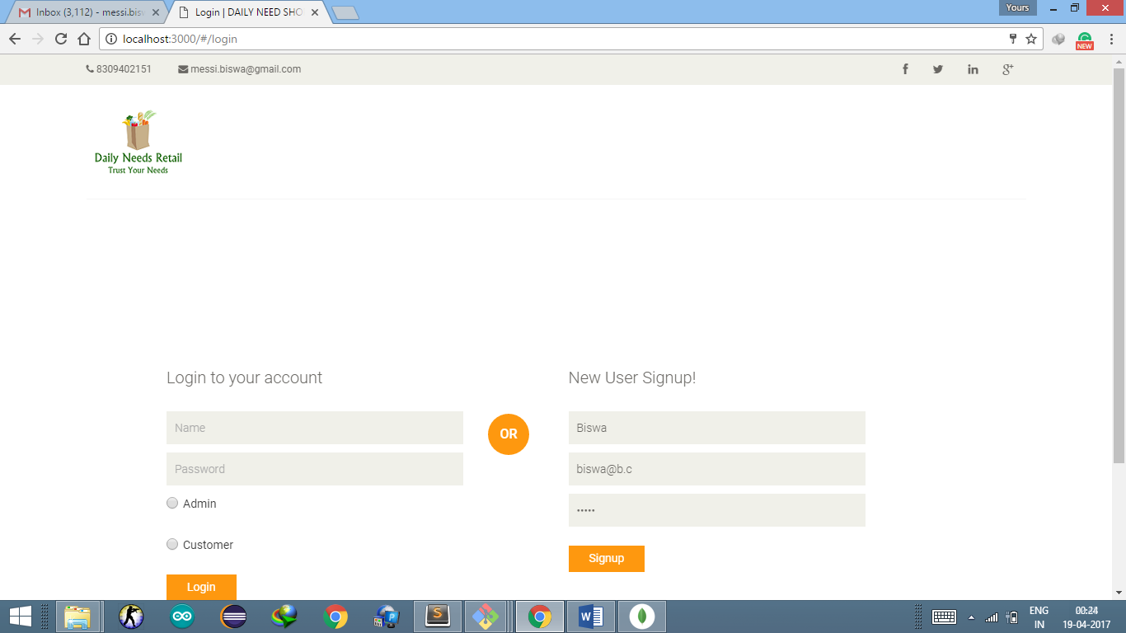

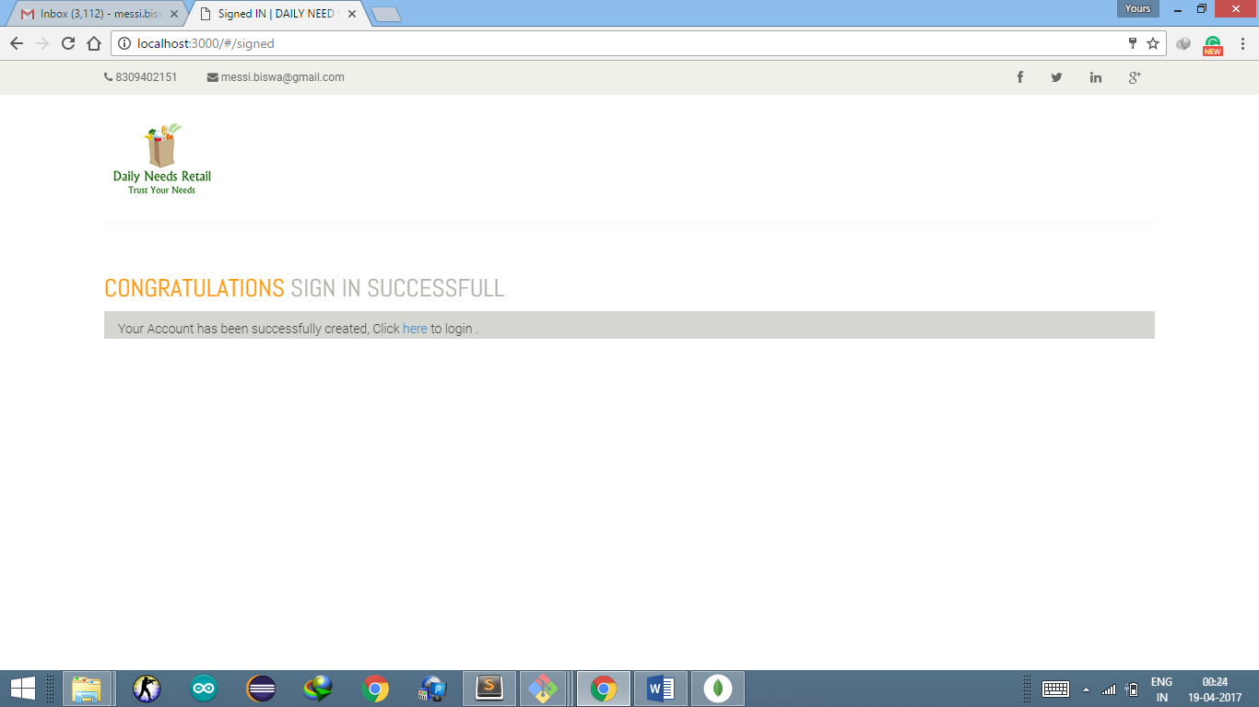

**Testing**

**Unit Test Cases**

Developed test cases using Mocha where Mocha is a feature-rich JavaScript test framework running on Node.js and in the browser, making asynchronous testing simple and fun. Mocha tests run serially, allowing for flexible and accurate reporting, while mapping uncaught exceptions to the correct test cases

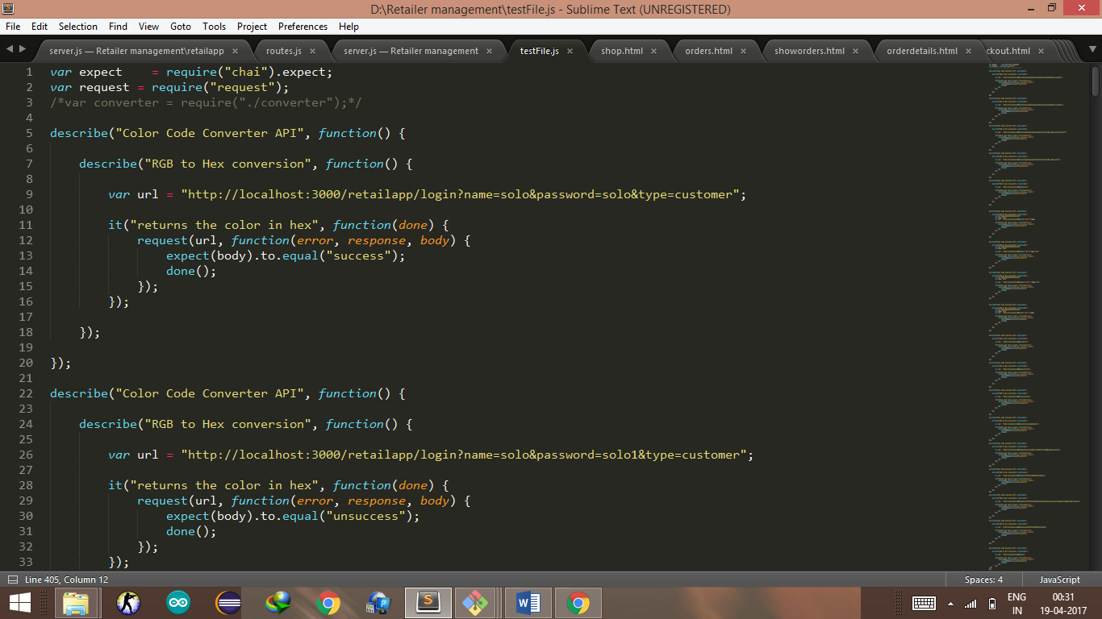

Example of a test case

In this way 26 test cases have been written to test each API

It is written in testFile.js and is tested by the command

mocha testFile.js

While the server.js running.

**Description of test cases**

|  |  |  |  |  |  |  |
| --- | --- | --- | --- | --- | --- | --- |
| Test  Case number | To Test | Input | Expected  Output | Output we got | Test Case  passed | Test  Case  Failed |
| 1 | Login Verification | Correct Username  password | success | success | ✓ | 🗶 |
| 2 | Login Verification | Wrong  Username  password | Unsuccess | unsuccess | ✓ | 🗶 |
| 3 | Signup  Verification | Name=Kasturi  Password=kasturi1  Email=Kasturi@k.c | Success | Success | ✓ | 🗶 |
| 4 | Signup  Verification | Name=Kasturi  Password=NULL  Email=Kasturi@k.c | Unsuccess | Unsuccess | ✓ | 🗶 |
| 5 | Search category of type “Biscuits” | Database must contain products of the same category | Success | Success | ✓ | 🗶 |
| 6 | Add to cart | id="58ebc385b0b4de05d46a37b1"  name="solo" | Success | Success | ✓ | 🗶 |
| 7 | Increase quantity | id="58ebc385b0b4de05d46a37b1"  name="solo" | Success | Success | ✓ | 🗶 |
| 8 | Decrease quantity | id="58ebc385b0b4de05d46a37b1"  name="solo" | Success | Success | ✓ | 🗶 |
| 9 | Remove from cart | id="58ebc385b0b4de05d46a37b1"  name="solo" | Success | Success | ✓ | 🗶 |
| 10 | Show products | Database must contains products information | Success | Success | ✓ | 🗶 |
| 11 | Show products in cart | Cart database must contain product information | Success | Success | ✓ | 🗶 |
| 12 | Show products in cart | Cart database do not have product information | Unsuccess | Success | 🗶 | ✓ |
| 13 | Checkout | Name=asd  Address=panjabari | Success | Undefined | 🗶 | ✓ |
| 14 | Add new product | Name=pizza  Price =100  Stock=100  Category=pizza | Success | Success | ✓ | 🗶 |
| 15 | Edit Product | Id=58f5f6fc15d1fd027c13e639 | Success | Success | ✓ | 🗶 |
| 16 | Update  Product | Id=58f5f6fc15d1fd027c13e639 | Success | Success | ✓ | 🗶 |
| 17 | Delete  product | Id=58f5f6fc15d1fd027c13e639 | Success | Success | ✓ | 🗶 |
| 18 | View Products  (Admin) | Product Database | Success | Success | ✓ | 🗶 |
| 19 | View  Orders  (User) | Order Database  Name=solo | Success | Success | ✓ | 🗶 |
| 20 | View  Bill  (User) | Order Database  Name=solo | Success | Success | ✓ | 🗶 |
| 21 | View  Orders  (Admin) | Order Database | Success | Success | ✓ | 🗶 |
| 22 | View profile | Login Database  Name=solo | Success | Success | ✓ | 🗶 |
| 23 | Save edited profile | Address=new address | Success | Success | ✓ | 🗶 |
| 24 | Update the status to Delivered | Id=58f317120b672e1e58e27cf6  Status=Delivered | Success | Success | ✓ | 🗶 |
| 25 | Update the status to Cancel | Id=58f317120b672e1e58e27cf6 | Success | Success | ✓ | 🗶 |
| 26 | Update the status to Return | Id=58f317120b672e1e58e27cf6 | Success | Success | ✓ | 🗶 |

**Result**

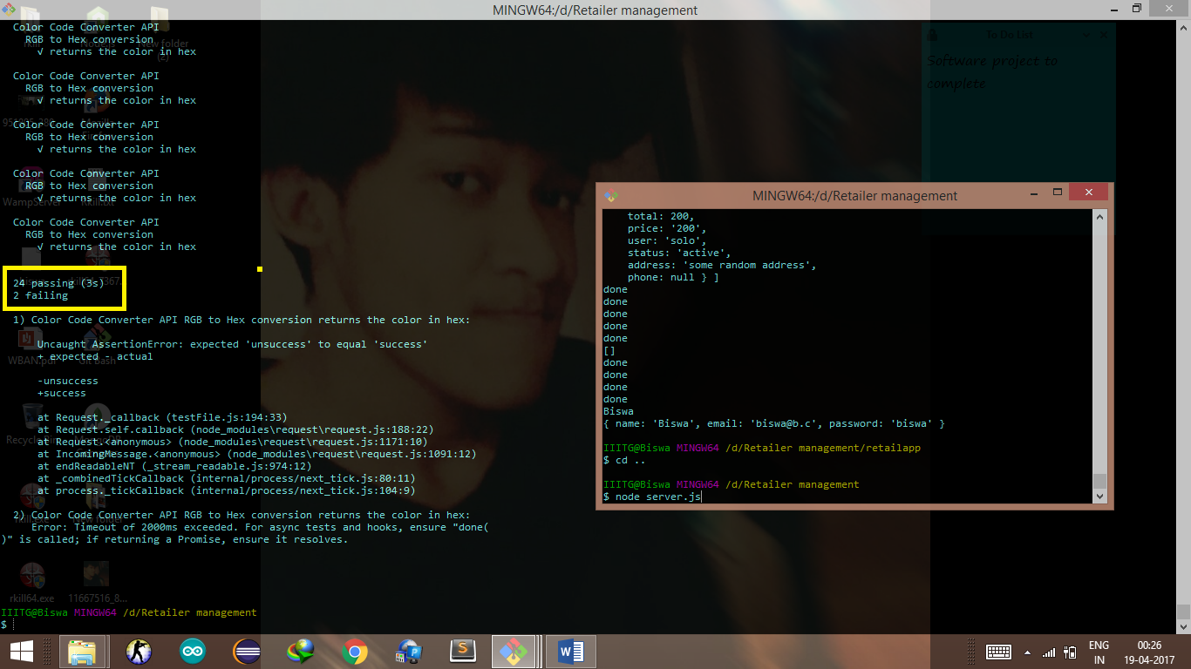

As in the following Screenshot it shows

24 passing

2 failing

As per the table.

**Conclusion**

The software can play an essential role in this growing age of technology where a user friendly interface can be used to manage the selling and billing of goods. Our contribution in building this software is to make it more efficient and user friendly for the user. This application can be further upgraded.